Aishwarya Solanki - Big Data Sys & Analytics - cs6220 P1.3

**Programming Assignment Problem 3: Hand-on Experience with Large Language Models**

* Learning tasks for the pre-trained models chosen:
  + **Sentiment Analysis**: Categorize feelings or opinions expressed in a piece of text.
  + **Data to Text Generation**: A classic problem in Natural Language Generation, it aims to generate concise results in form on text from a dataset provided.
* 3 pre-trained LLMs chosen:
  + **GPT-3.5-turbo**: Tends to be faster and slightly more deterministic. It is known to require higher temperatures for a relatively more creative outputs.
  + **GPT-4**: It is known for understanding capabilities and nuanced reasoning. It is known to provide better analysis at lower temperatures.
  + **GPT-4-turbo-preview**: It is optimized for speed; the response value is expected to be lightning fast. Main test is how it compares to its predecessor – GPT-4.
* Experimented with different hyper-parameter values for:
  + **Temperature**: It controls the creativity and randomness of a model’s output response. Higher temperature values give more diverse answer where lower values gives more expected answers.
  + **Top-p sampling**: As the name suggests, this value will consider top such values that are above a certain threshold and eliminate other values.
  + **Presence-penalty**: It is like encouraging creativity in a child. The more the value, the newer topics it will introduce and with lower value, it will stir towards repetitive patterns.
  + **Settings used**: (These will be referred throughout the document as for e.g. “Creative” hyper-parameter setting)
    - **Conservative**: Temperature: 0.2, Top-p: 0.5, Presence-penalty: 0.0
    - **Creative**: Temperature: 1.0, Top-p: 1.0, Presence-penalty: 1.0
    - **Balanced**: Temperature: 0.7, Top-p: 0.9, Presence-penalty: 0.5
* Minimum of 5 different query types from the following types:
  + **Zero-Shot Prompting:** No examples provided; ask the model to perform the task directly.
  + **One-Shot Prompting:** Provide one example and then ask the model to perform the task.
  + **Few-Shot Prompting:** Provide a few examples before asking the model to perform the task.
  + **Chain of Thought Prompting:** Encourage the model to reason step-by-step to arrive at an answer.
  + **Tree of Thoughts Prompting:** Encourage branching reasoning where the model considers multiple possibilities before arriving at an answer.
* Code snippet used to call the openai API

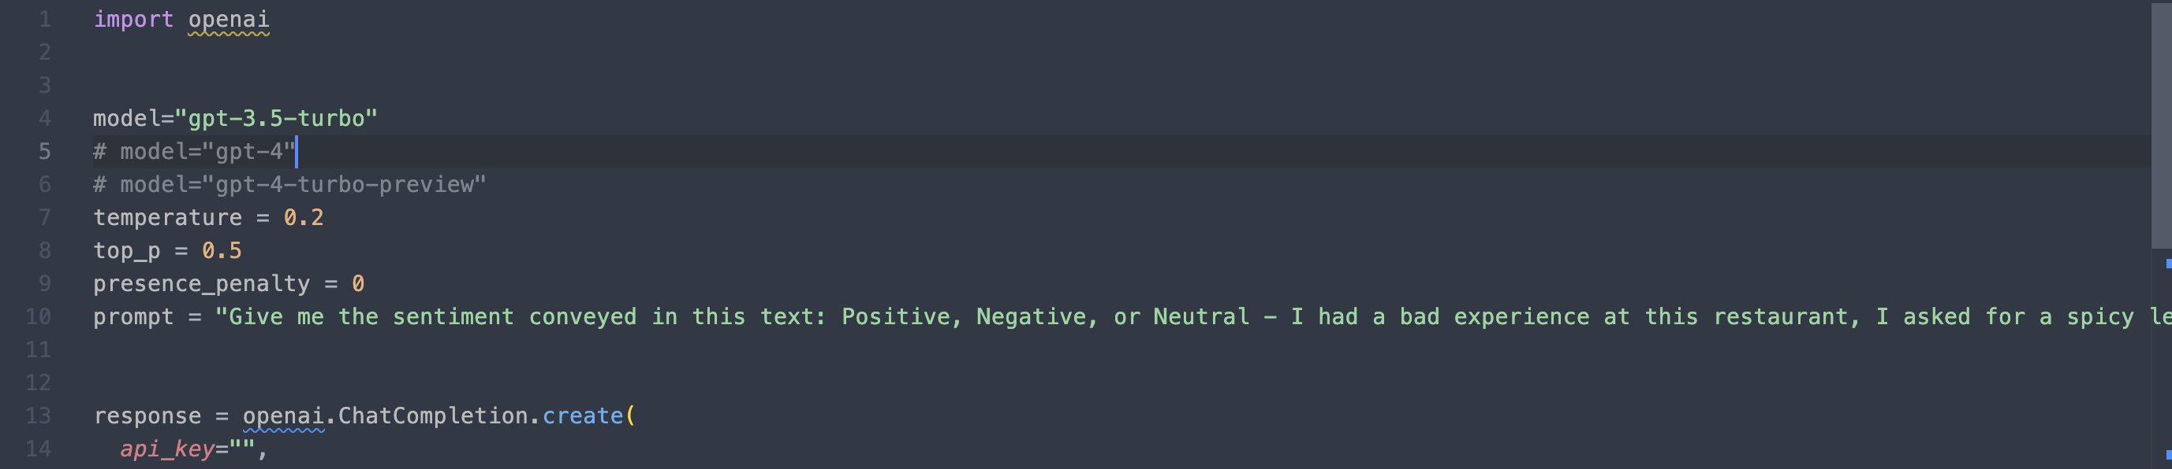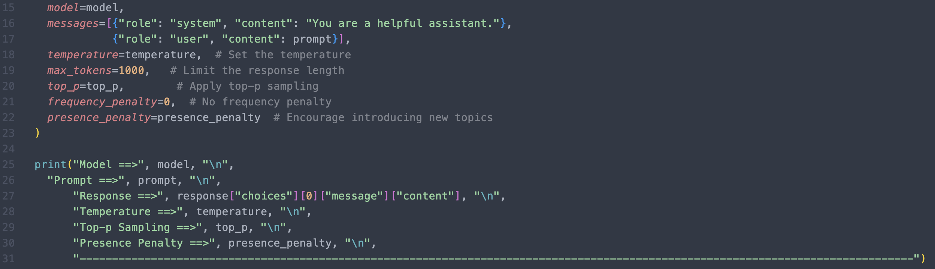

There were many learning tasks prompts I considered before zeroing in on the mentioned two like Code completing, plagiarism checking in code blocks, pin-pointing clauses of worry in legal documentations, Conversational-AI, Picking out the sentence that summarizes the entire paragraph or is the most important in a paragraph which can be useful while grading high-level English language tests like GRE, TOEFL, or Picking out what qualities does a candidate show while answering an interview question for a job roles, Code comment generator, Grammatical error correction, Natural Language Interference, and Fake news Detection.

While these are great topics for research, there are basic things that a pre-trained LLM can get wrong. So, first things first, let’s see how GPT models perform on these basic tasks that we as human don’t get wrong too often. For e.g., we can sense the sentiment of a sentence, but we can ignore certain wordings in a legal document that might get us in trouble. As for Data to text task, it can come in very handy when one wants to get a conclusive idea from a set of data points. So, for correctness’s sake, I have chosen the two learning tasks which are elaborated as below.

Sentiment Analysis

List of 5 Queries to be asked to 3 different models:

1. **Zero-Shot prompting** - I had a bad experience at this restaurant, I asked for a spicy level 5 and it was bland. The service was too slow, the place was filthy.
   1. **Correct/Expected Answer**: Negative. The text obviously shows that the user was displeased by the restaurant experience first, by the “bad experience” phrasing then going on and explaining how the restaurant got their spice levels incorrect and how the place was unkept and dirty. Below are the GPT answers for comparison.
   2. GPT-3.5 –

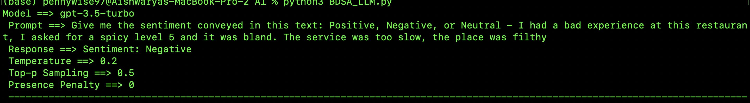

* 1. GPT-4-

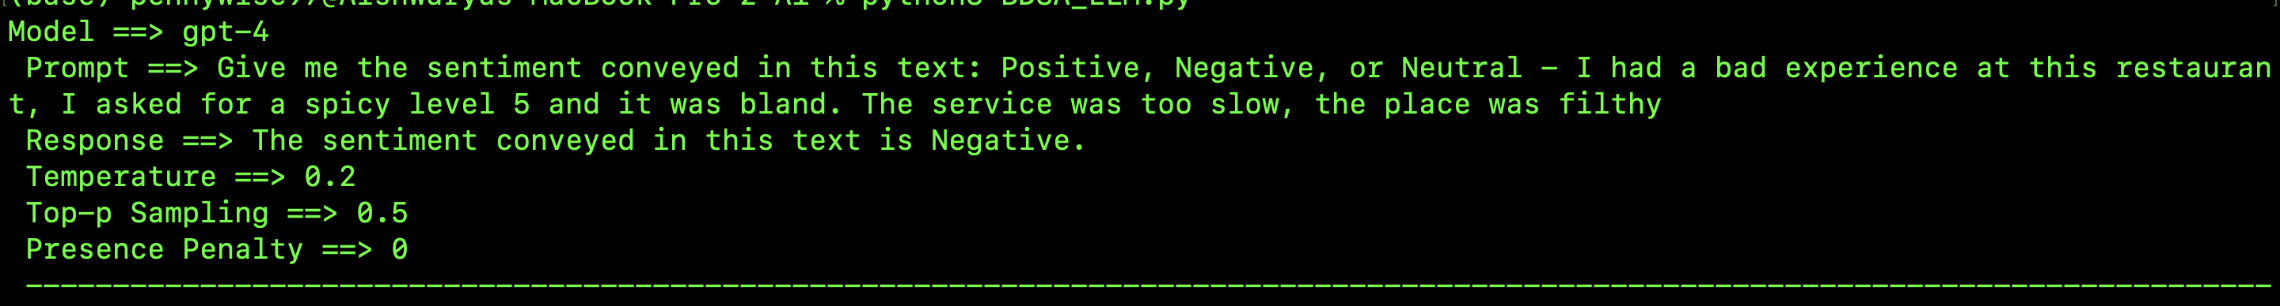

* 1. GPT-4-turbo-preview-

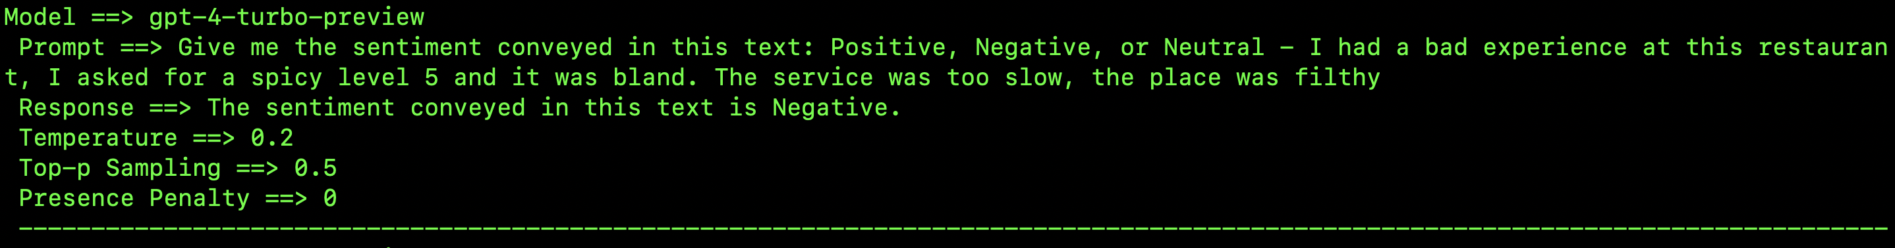

* 1. Comparison – It was a very simple task, with all different settings as well, the GPT models seem to perform just fine and output the correct answer. Although, one point to note here is that, while the GPT-3.5 shows the answer formatted in a very simple way, the GPT-4 models output an entire sentence conveying the same output, it would be cool to see how they perform with few-shot prompting as below.

1. **One-Shot prompting** - “I am fine.” Sentiment – Neutral. “The weather is just right today, nothing too special or too extraordinary about it.” Sentiment – [Your Answer]
   1. **Correct/Expected Answer**: Neutral. The first statement was to give an example to the LLM engine on how to identify a neutral statement. Contrary to the social media belief that when someone says “I am fine” they are not actually fine, I am considering this a neutral statement because common literature suggests the same for the purpose of this experiment.
   2. GPT -3.5 –

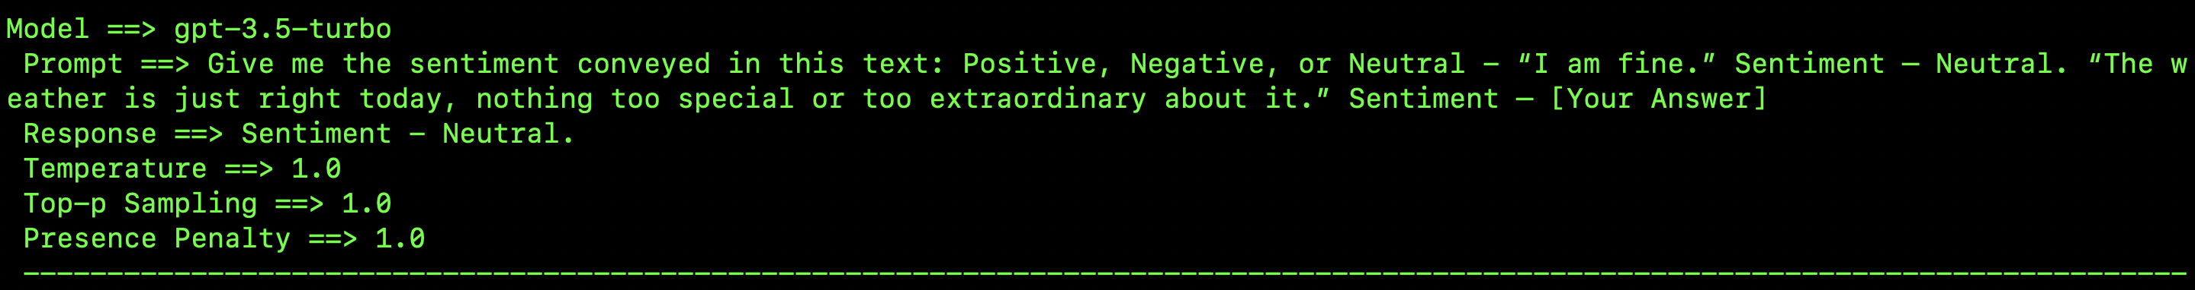

* 1. GPT -4-

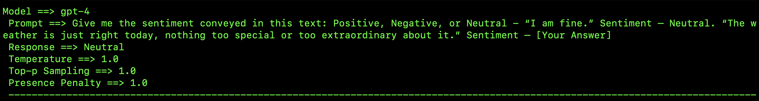

* 1. GPT-4-turbo-preview-

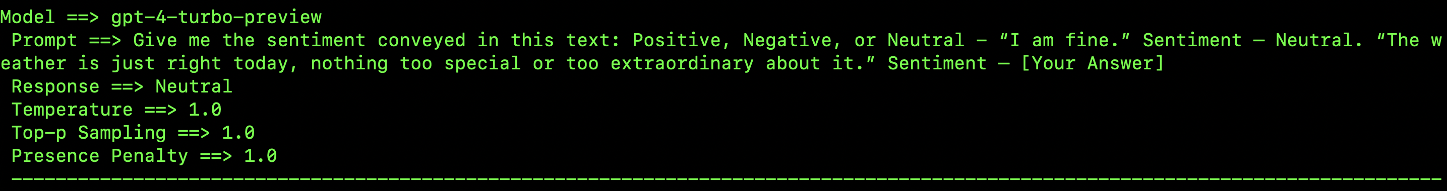

* 1. Comparison- Again, a simple enough task it would be surprising if they output anything other than the existing answers. The “Neutral” sentiment is in fact the correct answer and with the conservative parameter setting the models have performed just fine. A thing to point out is how well the GPT-4s have learned the format of the answer while GPT-3.5 still outputs in the same format as it did for zero-shot prompting. With creative hyper parameter settings, I wanted to see if it steers into an incorrect direction but the models have stayed on track. Maybe, a more complex scenario would be a better judge of the parameter values.

1. **Few-Shot prompting** - “My Big Data professor is so knowledgeable. She has an enormous set of projects and topics she specializes in, and her way of imparting knowledge is amazing too. The projects are well-though of too.” Sentiment – Positive. “Critics argue that recent improvements in the school system are merely superficial.” Sentiment – Negative. “The product arrived on time; it is in working condition, but the packaging was damaged in transit.” Sentiment – Neutral. “Educational technology has the potential to revolutionize learning, but it also poses risks.”. Sentiment – [Your Answer]
   1. **Correct/Expected Answer**: Neutral is the correct sentiment. Although one would say it leans towards Negative but the sentence has both positive and negative bits and that is why Neutral would make more sense in this case.
   2. GPT-3.5-

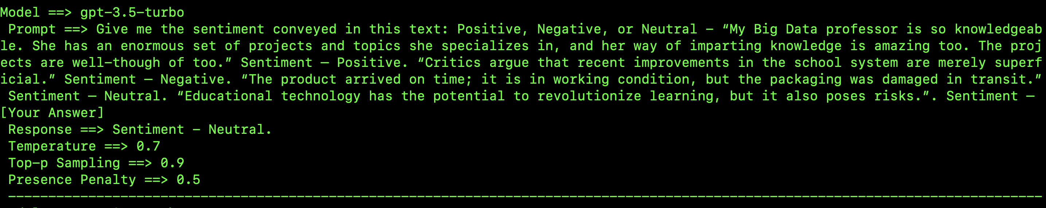

* 1. GPT-4-

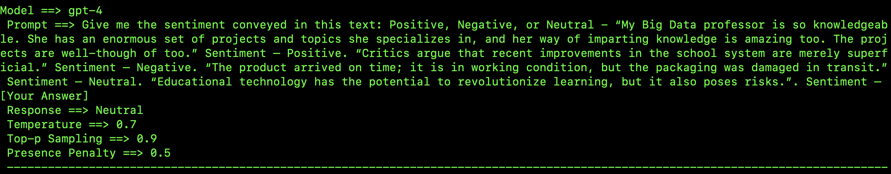

* 1. GPT-4-turbo-preview-

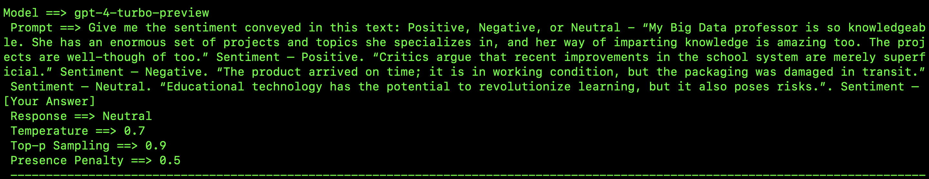

* 1. Comparison- As expected, the GPTs have output the correct sentiment values as expected. With a balanced hyper-parameter setting, we are both encouraging other thoughts and limiting creativity, for an overall balanced answer.

1. **Chain of Thought Prompting -** “While the current government has shown several improvements in some areas, I feel they aren’t even trying in some key areas. It pains me to see half-hearted work and empty promises that are filling the public up with false hope. On the other hand, I do understand that change takes time and not any government can work on all the changes they promise in a short tenure of 4 years. I acknowledge some hope for sure but I feel like I am moving farther away from the ray of light.” Sentiment – There is a mixture of emotions presented in this sentence. The first sentence has two parts, the first part is critical hence, negative and the second part is appreciative, hence, positive. The second sentence depicts negative emotion. The third sentence displays hope, so positive. Fourth sentence shows negative sentiment. Since, the dominating sentiment is negative, the overall sentiment of this statement can be considered Negative. “The new software update looks great and introduces some very useful features, but it’s filled with bugs that make it nearly impossible to use efficiently. I appreciate the effort to innovate, but the lack of attention to quality control is incredibly disappointing. I really want to love it, but it's just not there yet. Although, it looks very promising to me and if it is all the good things they say it is, I am totally sold.” Sentiment – [Your Answer]
   1. **Correct/Expected Answer:** The overall sentiment is Neutral in this sentence. There is a mix of positives and negatives in all the sentences. Like the first statement has positives - The new software update looks great and introduces some very useful features, negatives - but it’s filled with bugs that make it nearly impossible to use efficiently. The second sentence has positives - I appreciate the effort to innovate, negatives - but the lack of attention to quality control is incredibly disappointing. The third sentence, positives - I really want to love it, negatives - but it's just not there yet. The fourth sentence, positive, hopeful but also aware that it is not the reality.
   2. GPT-3.5-turbo-

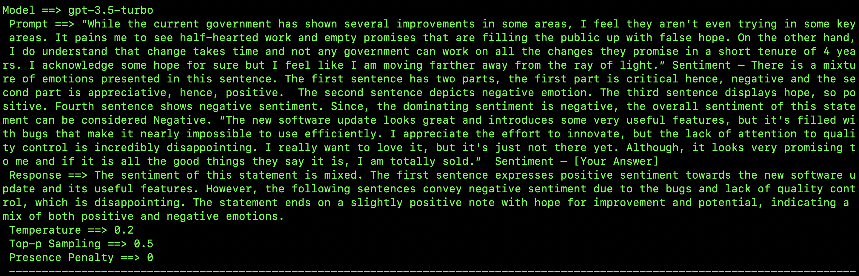

* 1. GPT-4-

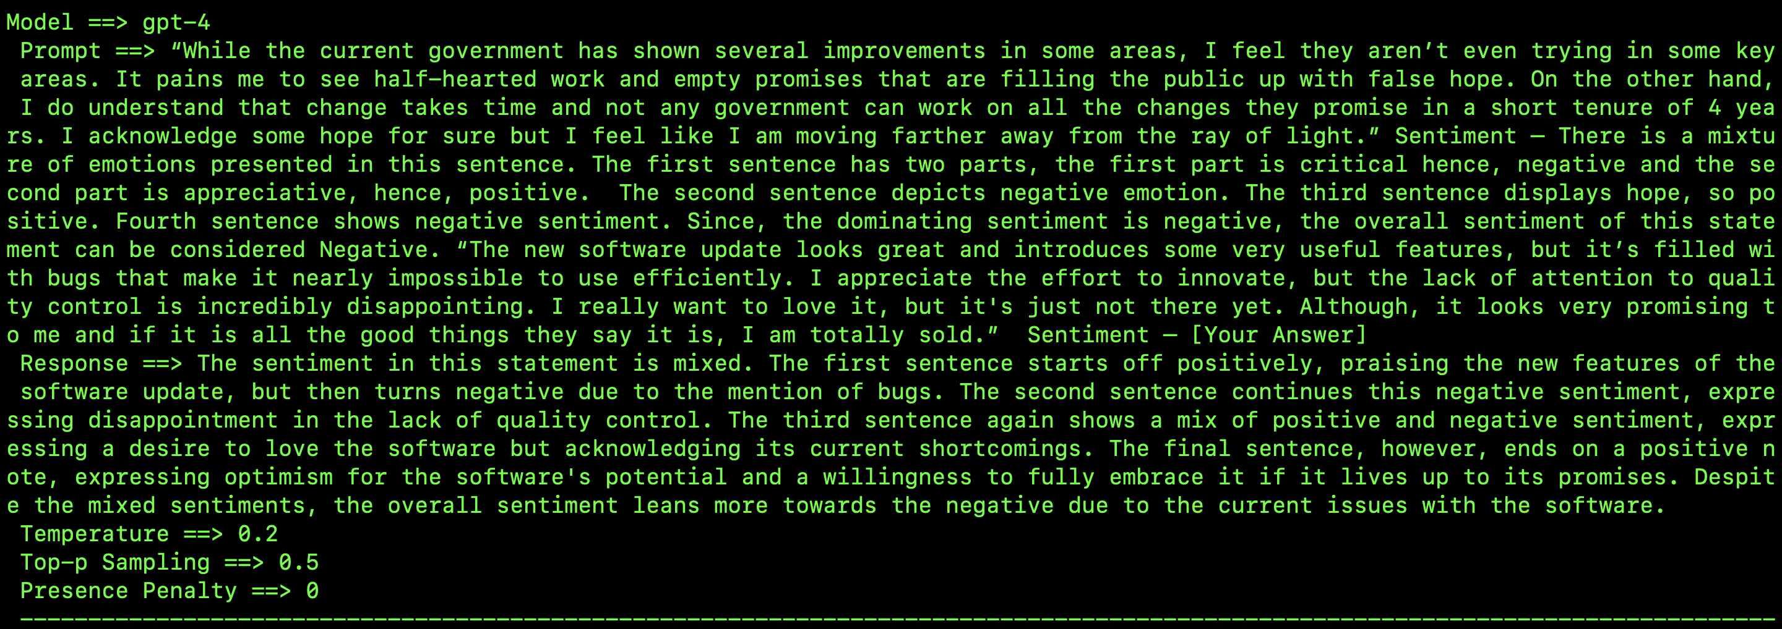

* 1. GPT-4-turbo-preview-

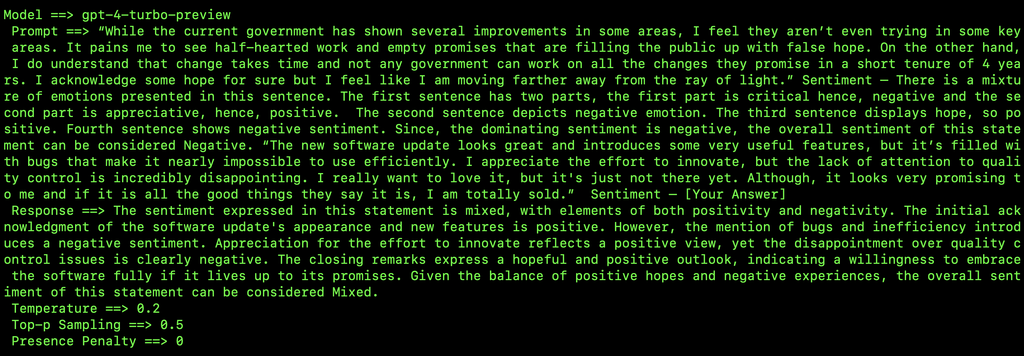

* 1. Comparison- A descriptive sentiment analysis response is the correct judge of what the LLM models are really upto and what is their process. The correct answer would be “Neutral” which seems to be where GPT3.5 goes towards, GPT-4 however steers towards “negative” while 4.5 comes back to a “Mixed” sentiment analysis. The behavior was expected with conservative hyper-parameter settings. It was a complex statement and it is evidently difficult to gauge even for some humans.

1. **Tree of Thoughts Prompting –** “The event was very well-organized, and the guest speakers were smart and well-versed. But I felt that the venue was too small for audience, and the sound system kept malfunctioning, making it harder and harder to hear the presentations clearly. Overall, I enjoyed parts of the experience, but the technical difficulties were frustrating.” Sentiment - Branch 1: Sentiment - Positive, Node 1: The first sentence, “the event was well-organized”, shows effective planning. Node 2: The second part of the first sentence, “The speakers were smart and well-versed”, indicates that the content was valuable and informative. Branch 1 Sentiment Evaluation: The user expresses clear positive sentiments about the event’s organization and the quality of the speakers. Branch 2: Sentiment - Negative, Node 1: The second sentence, “But I felt that the venue was too small for audience”, which suggests it caused discomfort due to overcrowding. Node 2: The second part of the second sentence, “The sound system kept malfunctioning, making it harder and harder to hear the presentations clearly”, states technical frustrations. Branch 2 Sentiment Evaluation: The user highlights multiple negative aspects of the event related to the physical setting and technical issues, contributing to dissatisfaction. Branch 3: Sentiment - Neutral, Node 1: The user acknowledges that parts of the experience were enjoyable, showing a blend of positive feelings. Node 2: However, the overall tone is tempered by frustration, as technical difficulties detracted from the experience. Branch 3 Sentiment Evaluation: The user’s sentiment is mixed, reflecting an appreciation for certain elements but frustration with others. Overall Sentiment – There seems to be more of negative sentiment going on and the final concluding statement also has a hint of negativity, so the overall sentiment of the text is Negative. “I really wanted to like this new phone. It has a stunning design, and the camera quality is amazing, but the battery life is terrible, and it keeps freezing during important tasks. While I appreciate the innovation, these issues make it hard to justify the price. I'm torn because it’s almost perfect, but the flaws are just too significant to ignore.” Sentiment – [Your Answer]
   1. **Correct/Expected Answer:** Branch 1: Sentiment – Positive. Node 1 - I really wanted to like this new phone, is a positive statement. Node 2 - the camera quality is amazing, is also a positive statement on the camera quality. Node – 3, but the battery life is terrible and it keeps freezing during important tasks – is a slight on the terrible battery life of the phone. Branch 1 Sentiment Evaluation – overall positive, because that is the dominating emotion. Branch 2: Sentiment – Negative. Node 1 - While I appreciate the innovation, is a positive statement showing there is room for innovation. It is also a counter-intuitive statement and not a strongly positive one overall. Node 2 - these issues make it hard to justify the price, is a negative statement. Branch 2 Sentiment Evaluation – Overall Negative. Branch 3 – Sentiment – Negative/Neutral. Node 1 - I'm torn because it’s almost perfect is a slightly neutral as well as negative remark. Node 2 - but the flaws are just too significant to ignore is a slightly negative sentiment as well. Branch 3 Sentiment Evaluation – Overall Negative or Neutral. The piece of text depicts both negative as well as positive sentiments, but Negative comments are more in number so the overall sentiment according to me would be Negative.
   2. GPT-3.5-turbo-

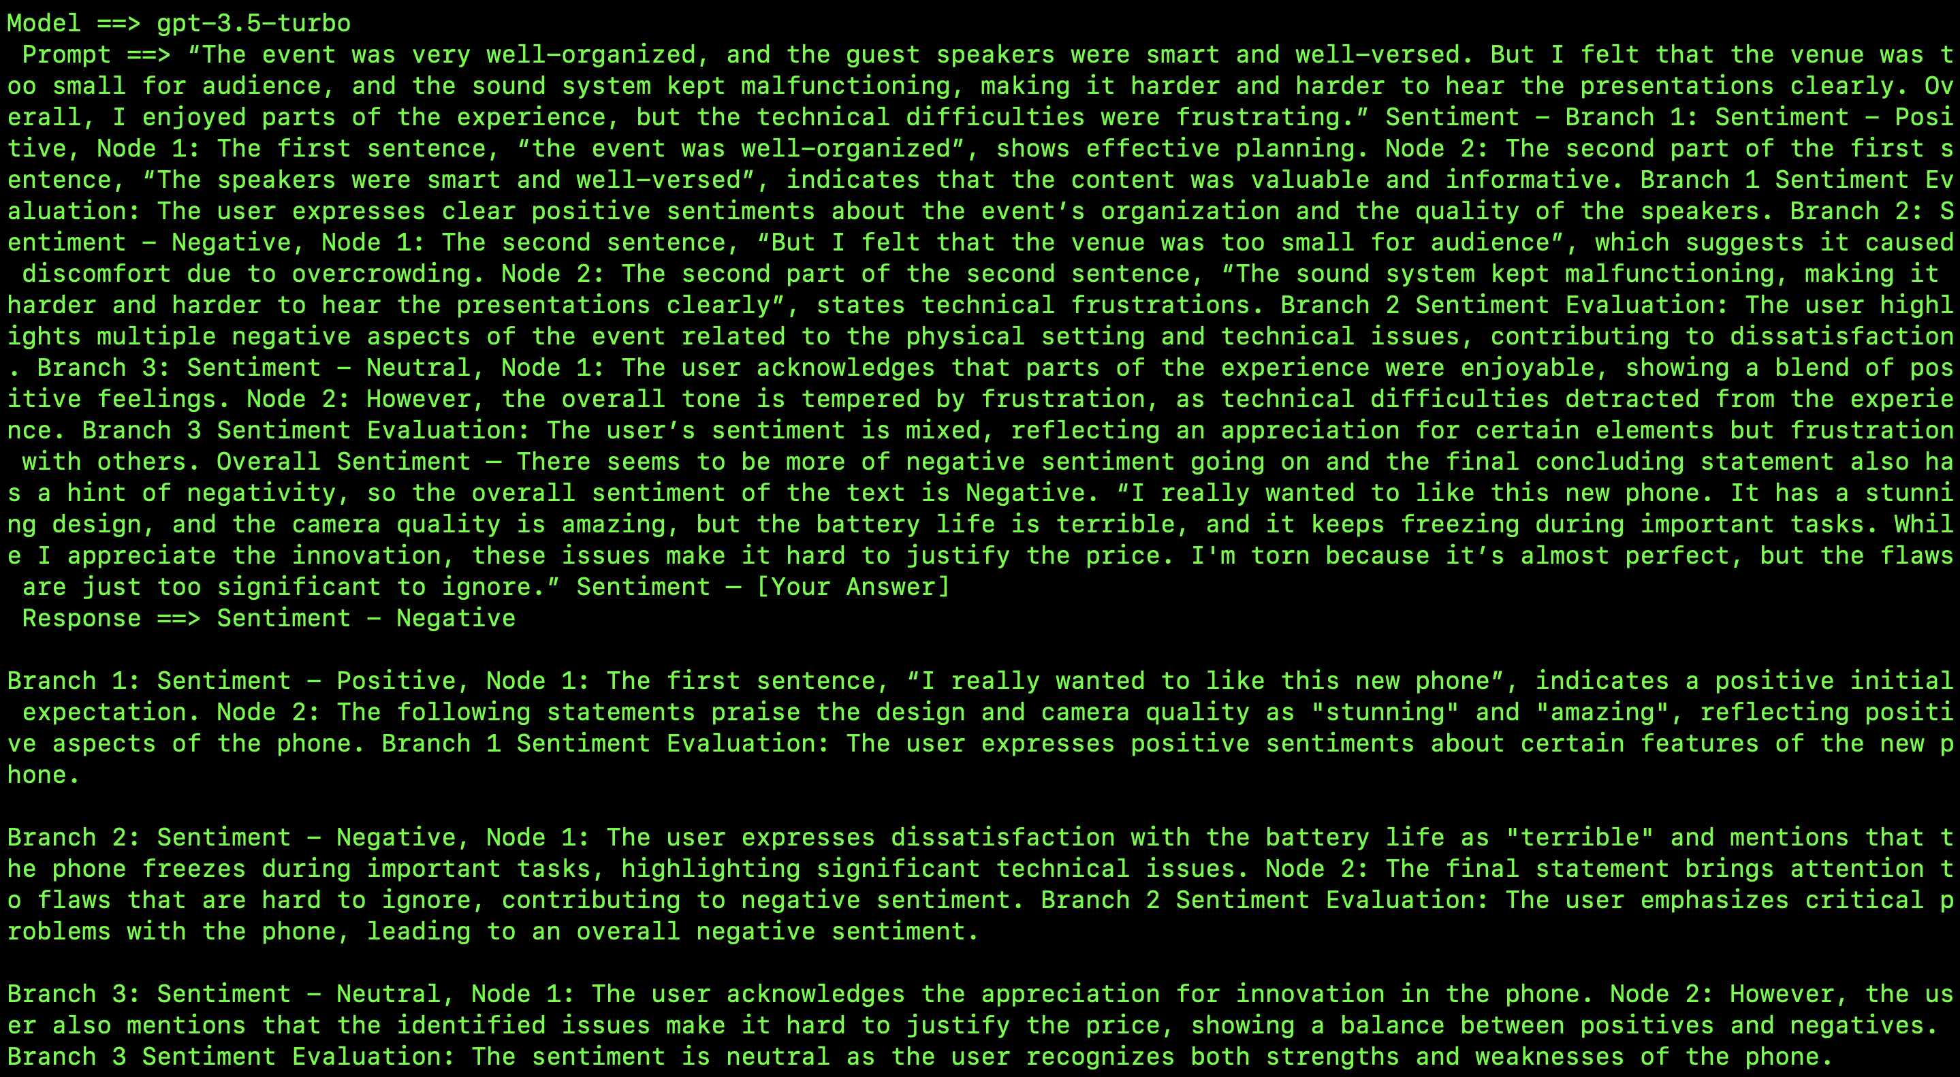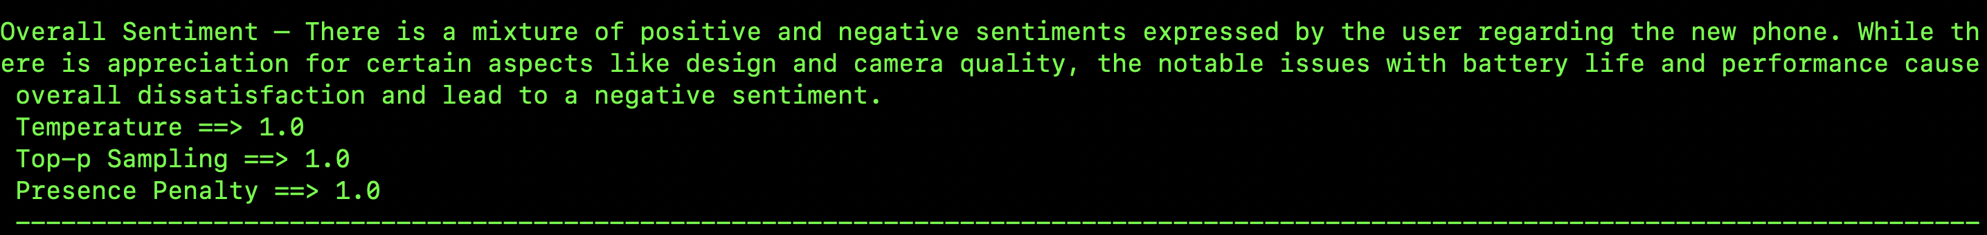

* 1. GPT-4-

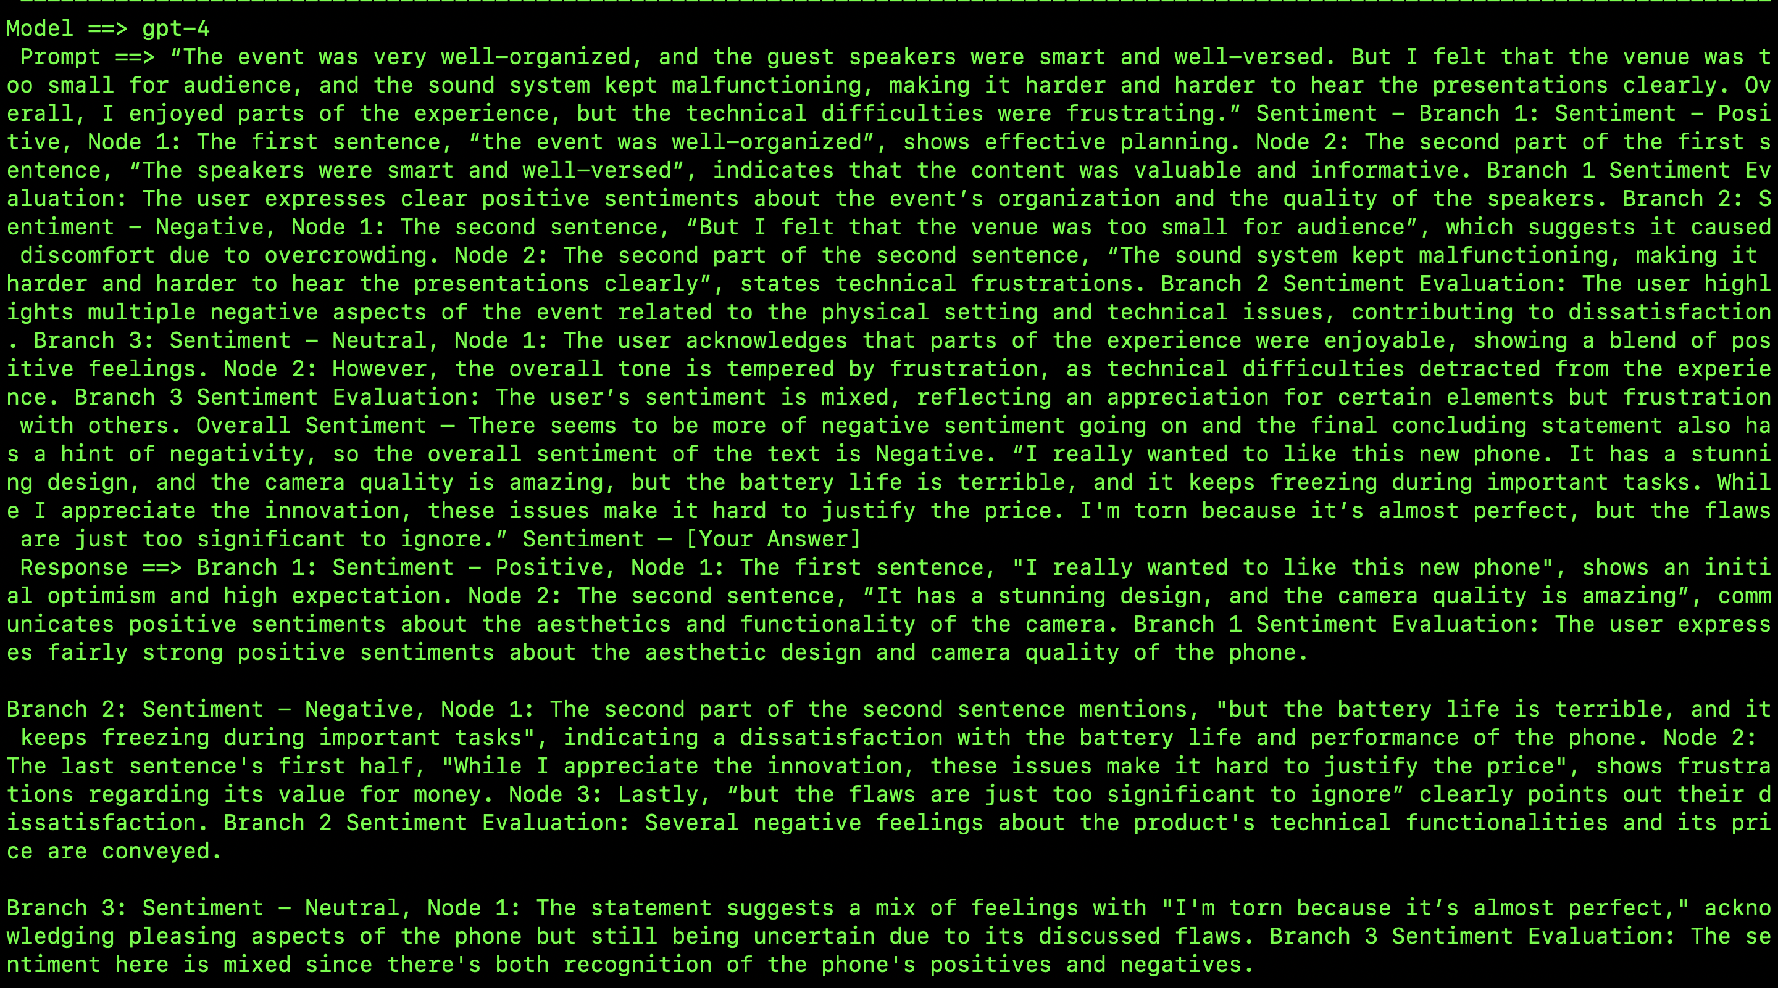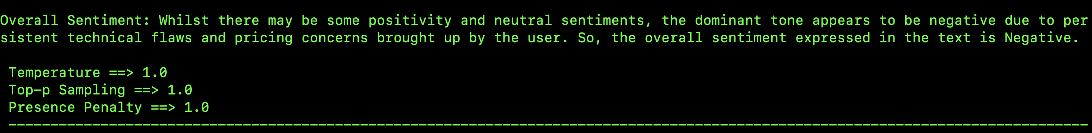

* 1. GPT-4-turbo-preview-

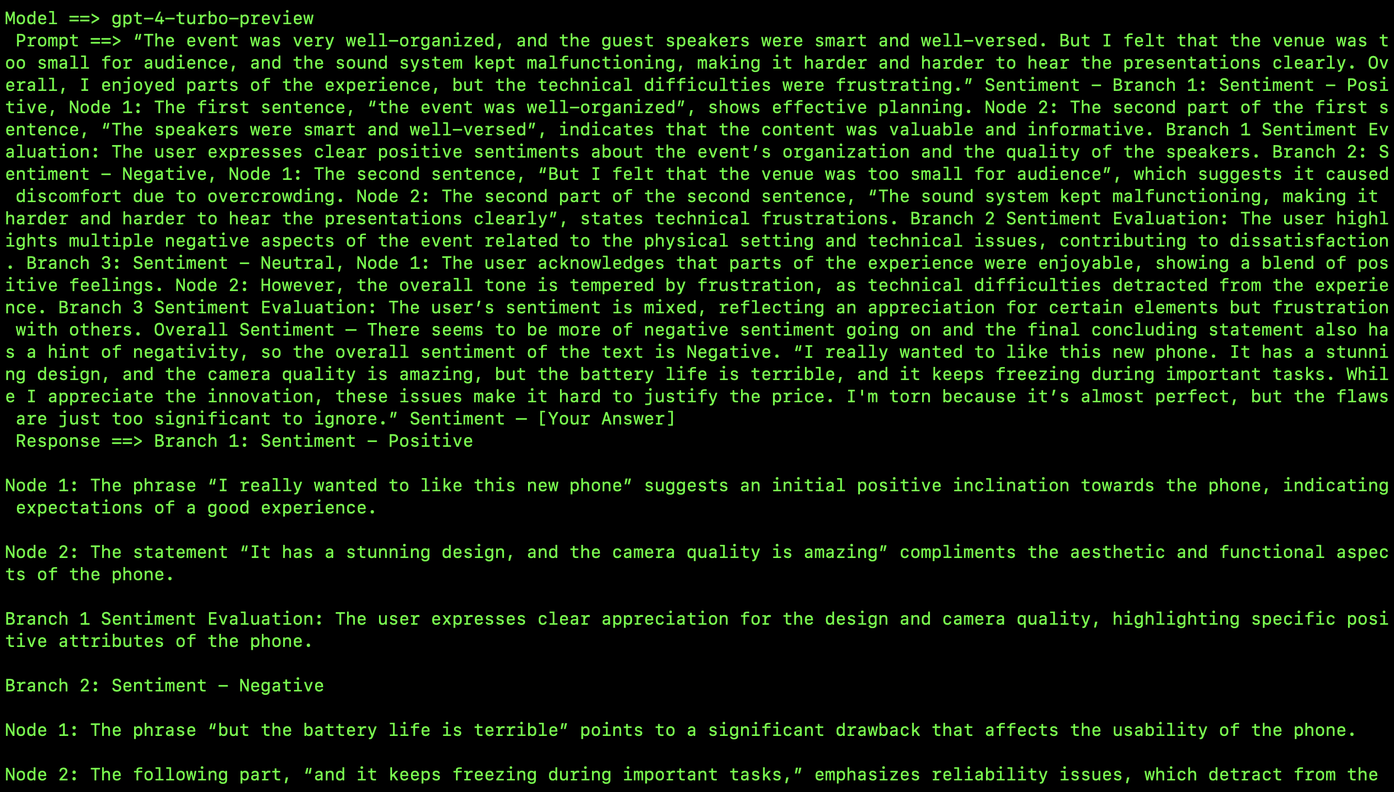

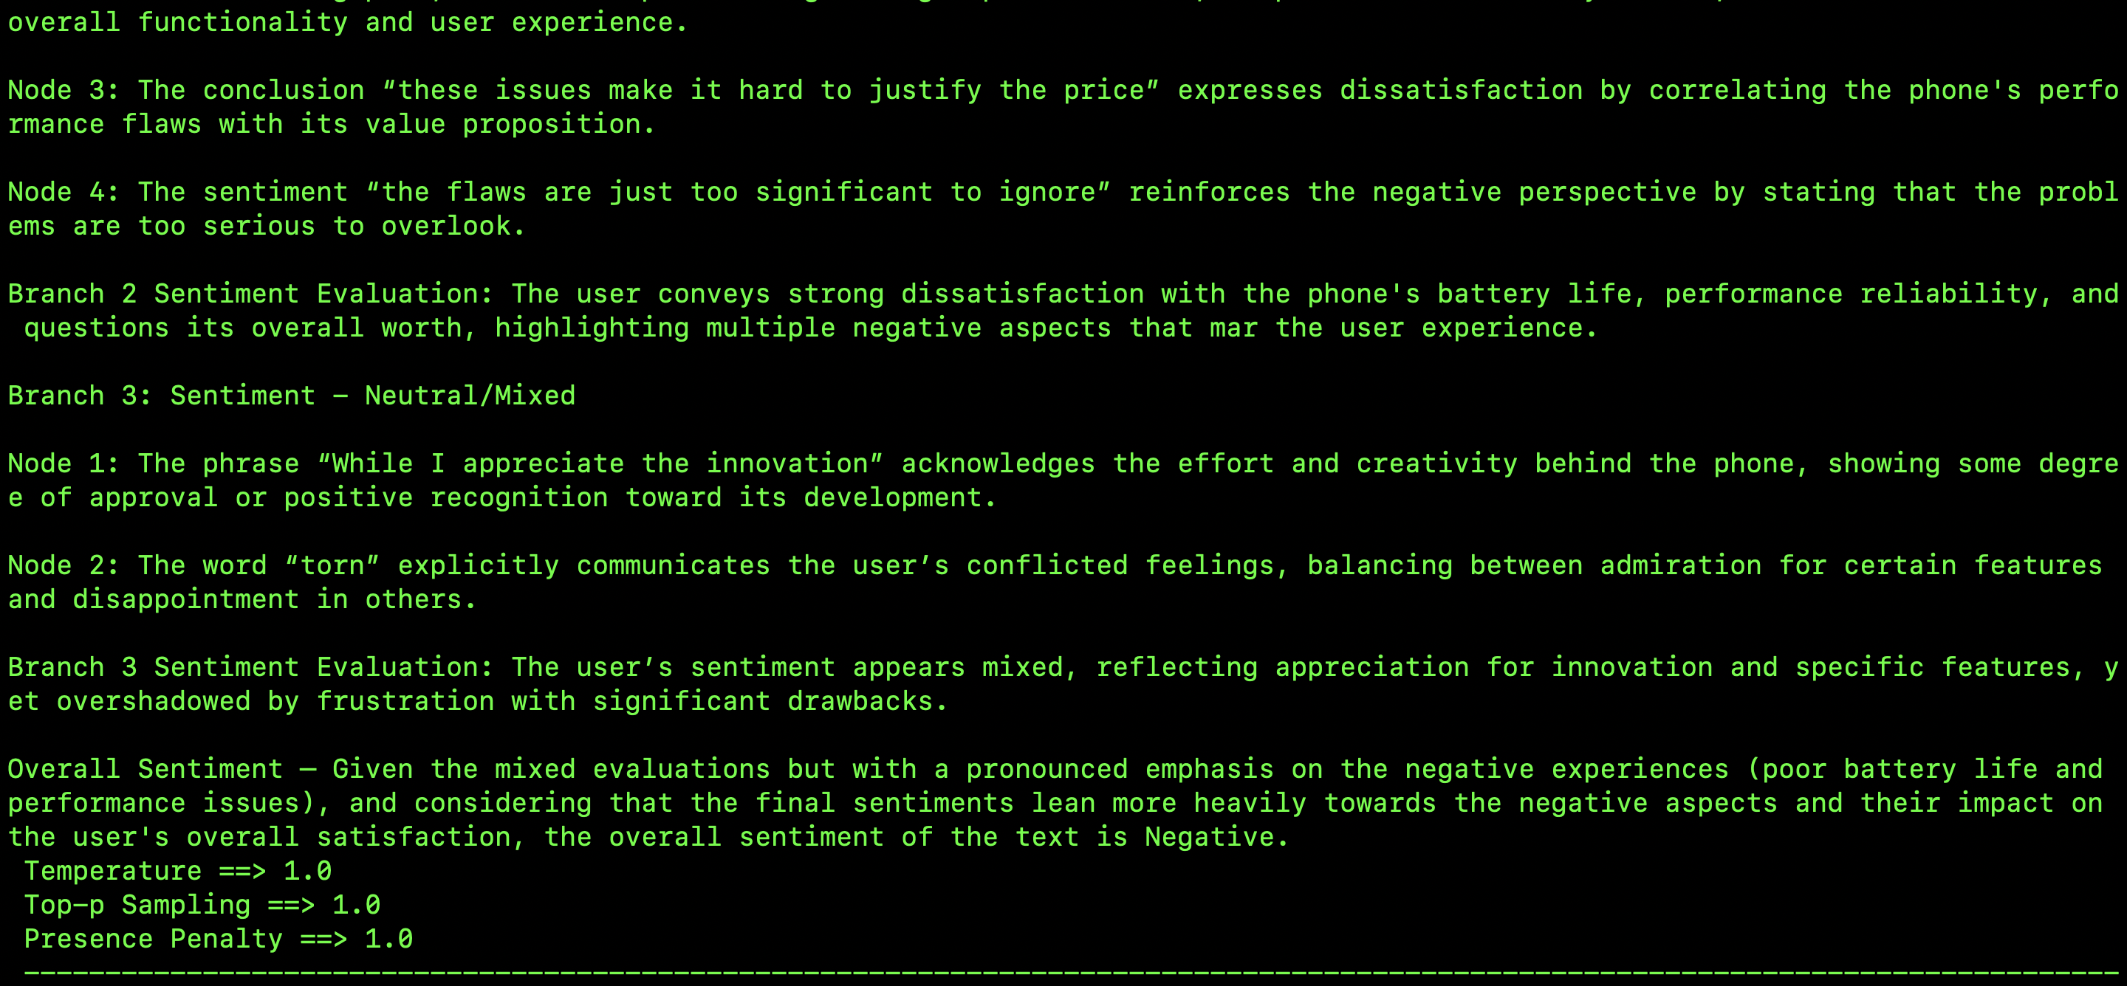

* 1. Comparison- It is a fairly complex statement and to top that off, a more creative hyper parameter setting was used as mentioned on the first page. All the models seem to get the overall sentiment of Negative, although a few branches and nodes have some variations with the sentiment analysis. For example, I would argue that the branch 3 is overall negative, but I understand that LLM would consider “almost perfect” as a positive sentiment, it seems hopeful and I would still accept a Neutral evaluation for the same. For the other parts, branch 1 is overall positive that is true for all models, and Branch 2 is Negative which is also true of all the models, the thing that changed the overall evaluation is how the model perceives the third statement, i.e. third branch and its two nodes as in the two parts of the sentences. Overall, the content of the response is thorough and as concluding thoughts for Sentiment Analysis, I think GPT models would make a great substitution for humans or other engines. Overall success rate is clearly 95%+.

Data to text Generation

List of 5 Queries to be asked to 3 different models:

1. **Zero-Shot prompting** - Given the data provided, generate a detailed product description in natural language - { "product_name": "Macbook Pro", "release_year": 2020, "processor": "Intel Core i9", "ram": "32 GB", "storage":"1 TB SSD", "battery_life": "10 hours", "price": "$1999", "customer_rating": 4.8 }
   1. **Correct/Expected Answer**: “The Macbook Pro, released in 2020, is a high-performing device powered by an Intel Core i9 processor. Boasting a 32 GB of RAM and a 1 TB SSD internal storage, this laptop is designed for demanding tasks such as programming, video editing, gaming, and intensive multitasking. It offers a battery life of up to 10 hours, ensuring productivity on the go. Priced at $1999, the Macbook Pro provides excellent value for its features, price, and built, as reflected by its impressive 4.8-star customer rating.” I am providing a data in the form of a json object, it can also be a data table, the job of the LLM is to provide a detailed output of what the data is trying to say that one cannot understand with a first look at it. Basically, through this task, I want the LLM to be able to explain the data in words. Data input table can look like the following, but since it will be difficult to provide data table via api call, I am sticking to json input.

|  |  |  |  |  |  |  |  |
| --- | --- | --- | --- | --- | --- | --- | --- |
| product_name | Release_year | processor | ram | storage | battery_life | price | Customer_rating |
| Macbook Pro | 2020 | Intel core i9 | 32 | 1 TB SSD | 10 hours | $1999 | 4.8/5 |

* 1. GPT-3.5-turbo –

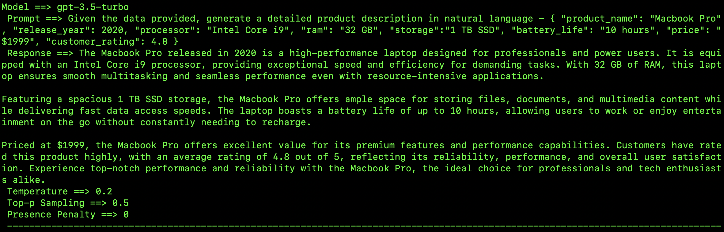

* 1. GPT-4-

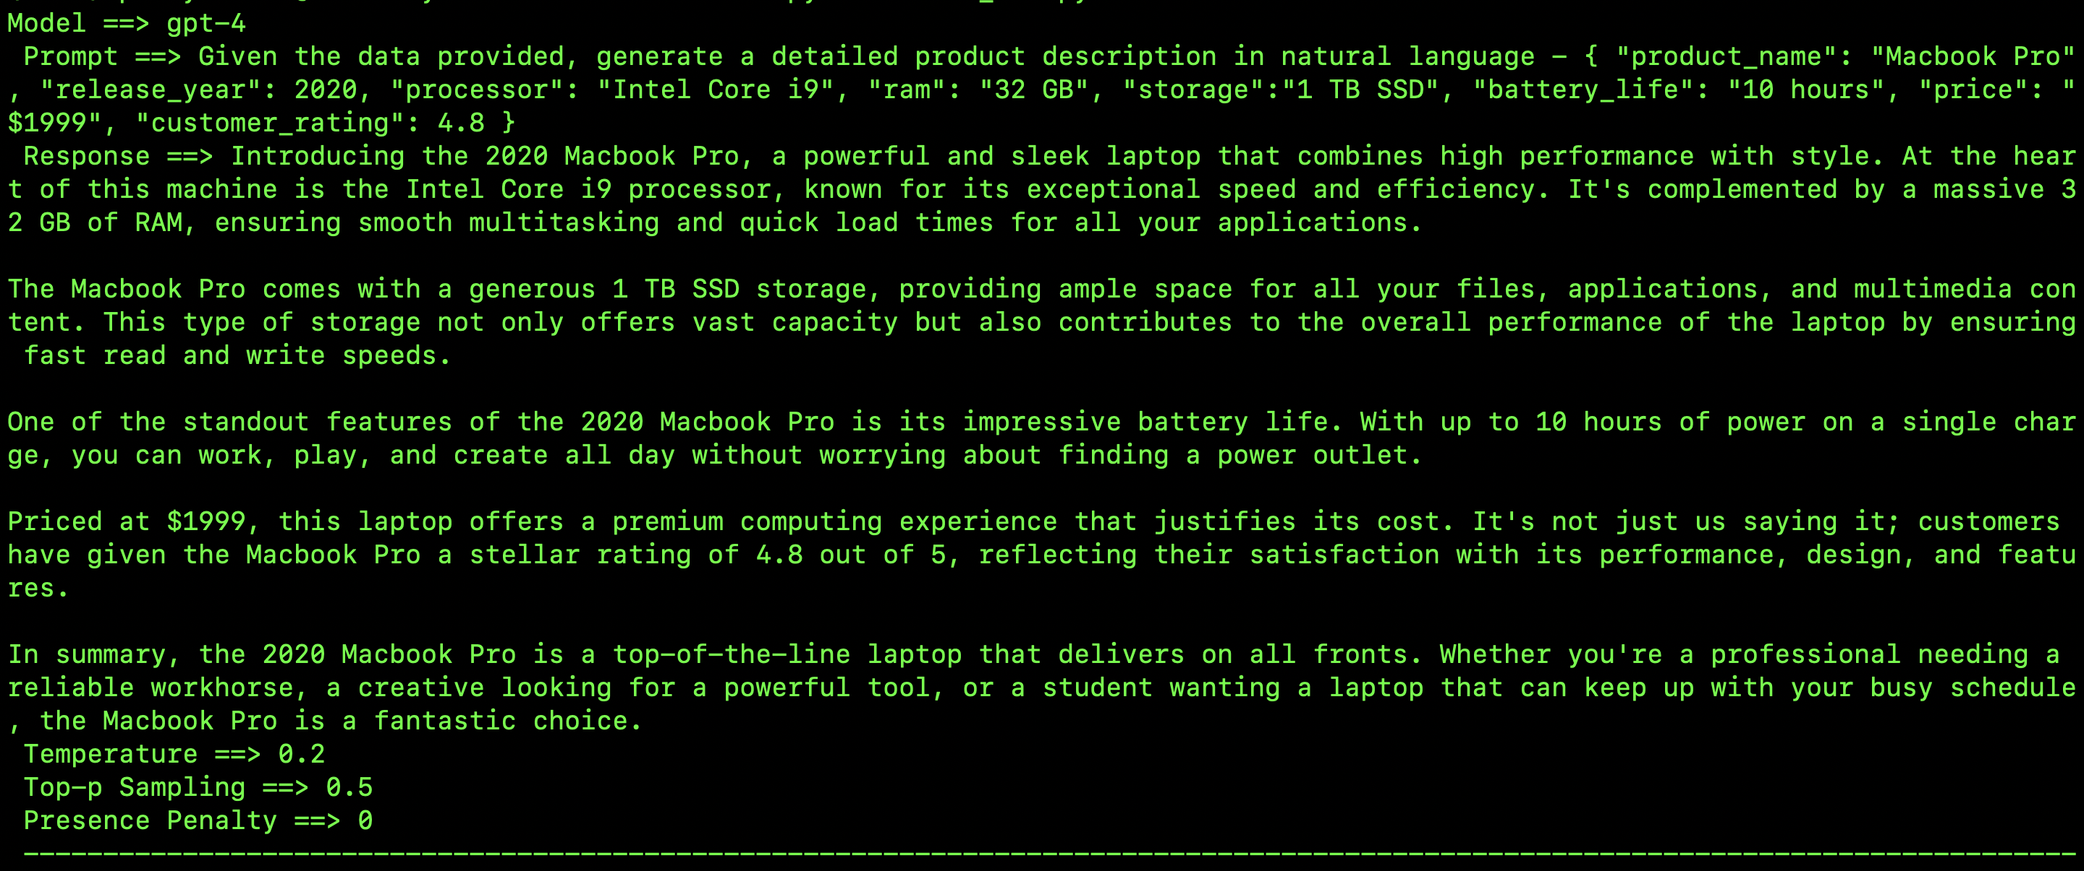

* 1. GPT-4-turbo-preview-

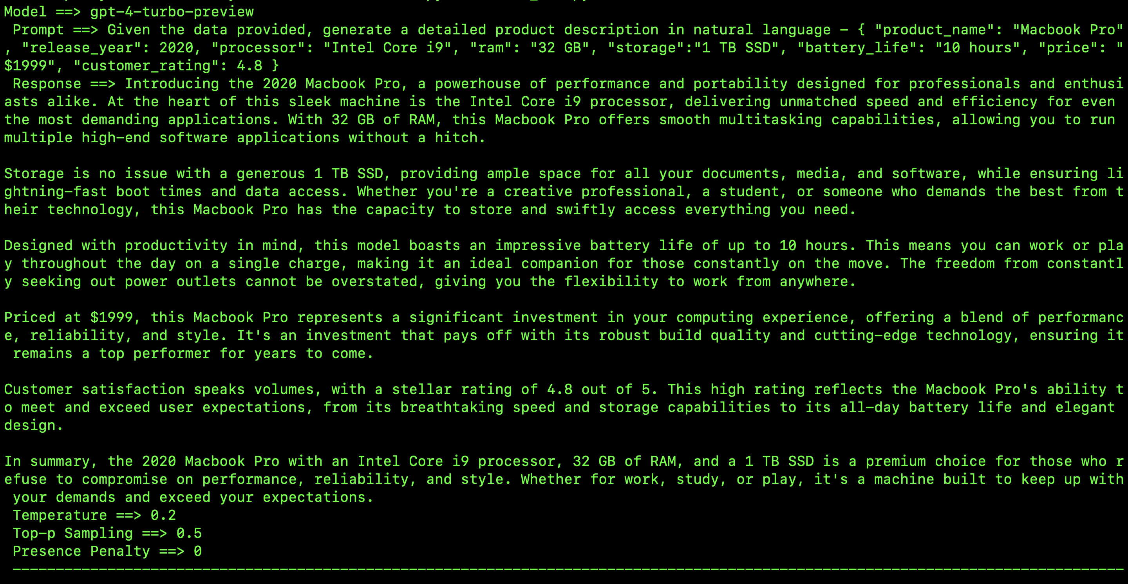

* 1. Comparison- This zero-shot prompting was a fairly simple one and with the conservative hyper-parameter settings, the GPTs seem to be doing a fairly sincere job in describing the product. Such descriptions can be helpful for sales and much more lucrative for customers who are otherwise not used to json data. This is one thing the GPT models are good at, elaborating an idea and as expected the response length also seemed to increase as the models advanced.

1. **One-Shot prompting**- Generate a performance summary for the following player data -{ "player_name": "LeBron James", "team": "Los Angeles Lakers", "position": "Forward", "points_scored": 25, "assists":8, "rebounds": 10, "steals": 2, "season": "2023-2024" }. Summary – Lebron James, a player for the Los Angeles Lakers had an outstanding performance in the 2023-2024 season. Playing as a forward, he contributed significantly with 25 points, 8 assists, and 10 rebounds. His 2 steals added to the team’s strong defensive play. LeBron’s well-rounded stats continue to show why he remains one of the top players in the league. Generate a performance summary for the following player data - { "player_name": "Stephen Curry", "team": "Golden State Warriors", "position": "Guard", "points_scored": 32, "assists":5, "rebounds": 4, "steals": 3, "season": "2023-2024" }. Summary – [Your Answer]
   1. Correct/Expected Answer: “Stephen Curry, a player from Golden State Warriors has a great performance in the 2023-2024 season. Playing as a Guard, he scored 32 points, assisted worth 5 points, and had 4 rebounds. His 3 steals added to team’s strong overall play. Stephen’s overall good performance continues to show why he is added to the list of all times greats in the basketball world.” Like the summary added for Lebron James, the second data is expected to output a similar player summary for Stephen.
   2. GPT-3.5-turbo –

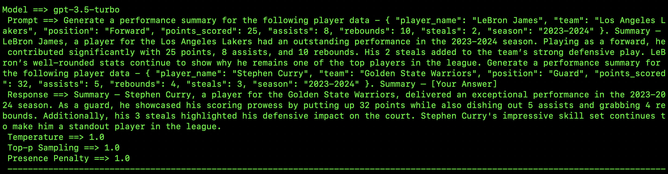

* 1. GPT-4-

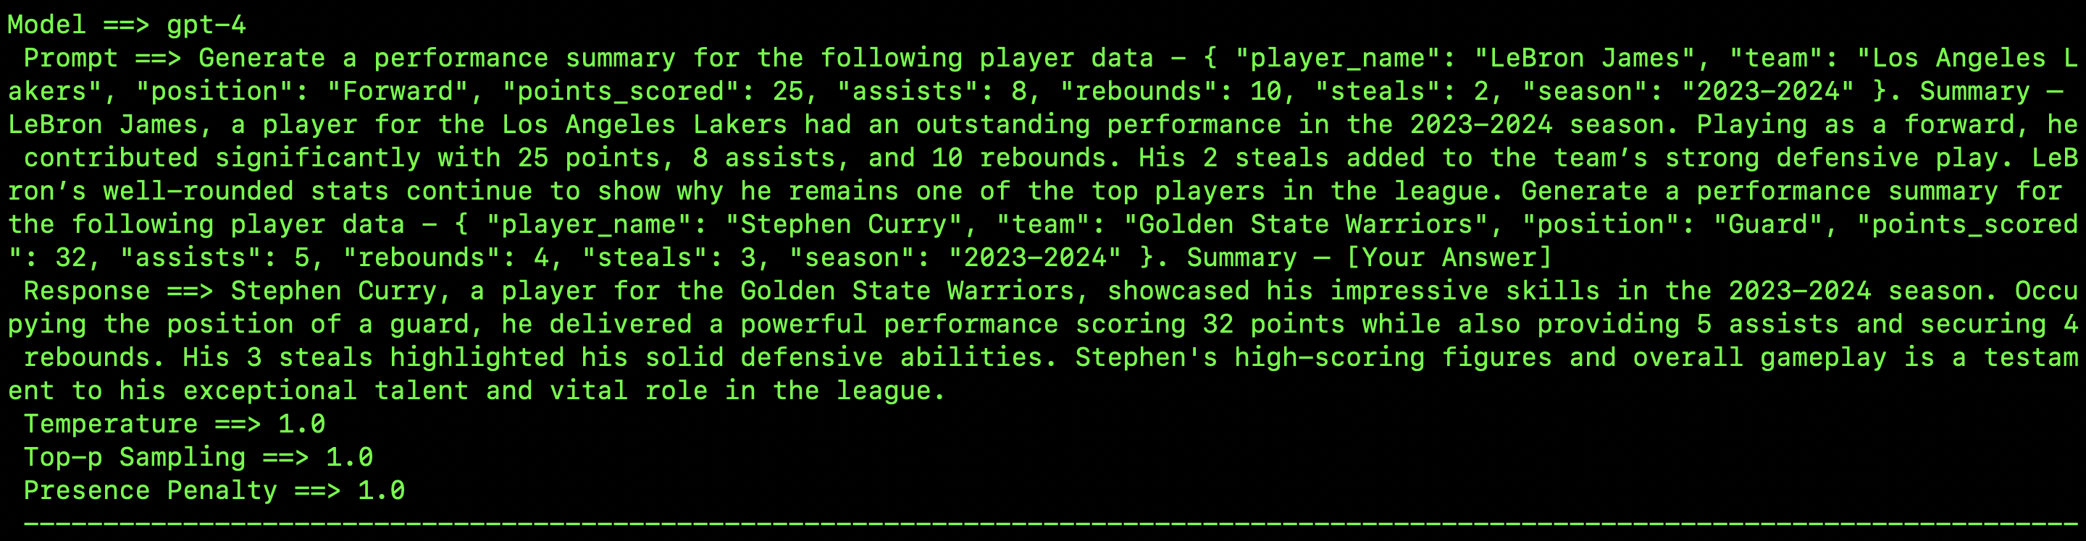

* 1. GPT-4-turbo-preview-

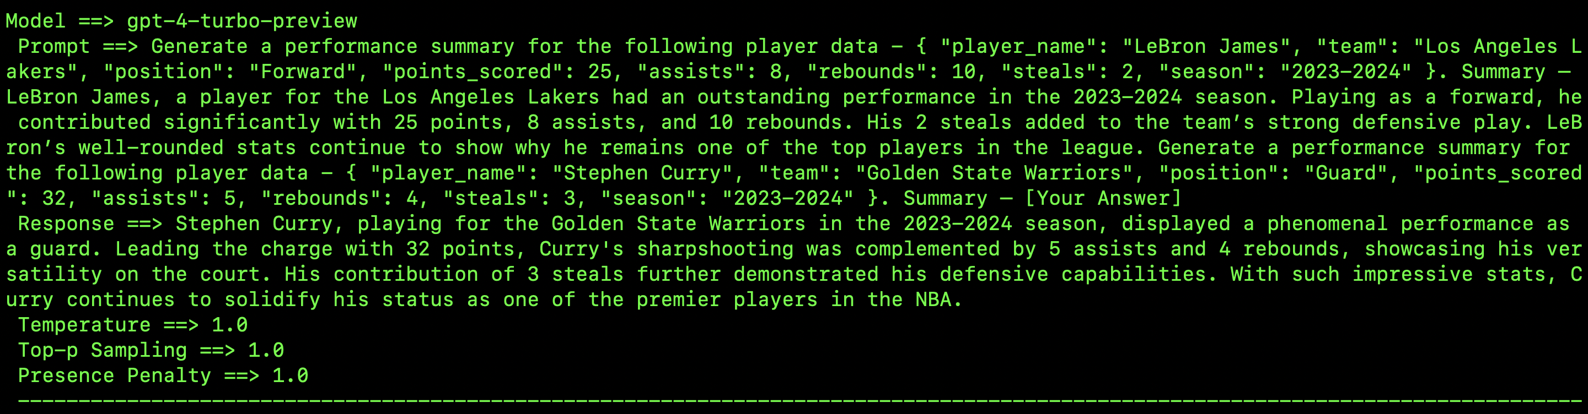

* 1. Comparison- Sports is a major use case for Data to text generation. As witnessed, the GPT models have done a good enough job provided an example. Although, I feel that the models have very closely tried to replicate it even with a creative hyper parameter setting. Surprisingly the length of the response has also stayed roughly the same. All the major points are covered in the description and it is thorough. I was expecting a progression like the previous example but since this is one-shot and models are supposed to learn from what you provide, I think they have done an excellent job.

1. **Few-Shot prompting**- Generate a performance summary for the following players data - “{ f1-Drivers: [{“name”: “Lewis Hamilton”, "nationality": "United Kingdom, British", "entries": { "total": 348,"starts": 348 }, "championships": 7, "wins": 105, "podiums": 201, "career_points": 4803.5, "pole_positions": 104, "fastest_laps": 67 }, {“name”: “Sebastian Vettel”, "nationality": "German", "entries": { "total": 300,"starts": 299 }, "championships": 4, "wins": 53, "podiums": 122, "career_points": 3098, "pole_positions": 57, "fastest_laps": 38 }]”. Summary – Lewis Hamilton, a British f1 racing driver had an extraordinary career with 7 wins under his belt. He has been very consistent with the same amounts of starts as the total number of entries. Lewis Hamilton has 7 championships under his belt and 105 wins with pole positions in 104 of them and fastest laps in 67 of them. He also has 201 podiums to boast for and a total career points of 4803.5. Sebastian Vettel on the other hand has had a great career as well. Coming from Germany, he has a consistent run with total starts only one less than the total number of starts. He has a total of 4 championships and 53 wins with 122 podiums and pole positions in 57 of them. Sebastian has 38 fastest laps and a collective total career points of 3098. In conclusion, while both drivers have had exceptional careers, Lewis Hamilton's statistics place him ahead in nearly all performance categories, cementing his status as one of the greatest drivers in Formula 1 history. Sebastian Vettel, with his 4 championships and 53 wins, is also recognized as one of the sport’s all-time greats. Generate a performance summary for the following players data - “{ f1-Drivers: [{“name”: “Charles Leclerc”, "nationality": "Monégasque", "entries": { "total": 141,"starts": 139 }, "championships": 0, "wins": 7, "podiums": 38, "career_points": 1291, "pole_positions": 25, "fastest_laps": 9 }, {“name”: “Max Verstappen, "nationality": "Dutch", "entries": { "total": 201, "starts": 201}, "championships": 3, "wins": 61, "podiums": 108, "career_points": 2889.5, "pole_positions": 40, "fastest_laps": 32 }]”. Summary - .
   1. Correct/Expected Answer: Charles Leclerc, representing Monaco, has had a noteworthy career in Formula 1 despite not securing a championship title. Out of 141 entries, he participated in 139 races, demonstrating consistency. Leclerc has achieved 7 wins and 38 podium finishes, reflecting his competitive edge and ability to secure top positions. With 1291 career points, he has shown consistent performance throughout his career. His 25 pole positions highlight his strong qualifying performances, although he has only managed 9 fastest laps. Max Verstappen, dutch driver, has a remarkable career in Formula 1, with three championship titles to his name. He has competed in 201 races, participating in all of them, showcasing his reliability and endurance. Verstappen’s impressive 61 wins and 108 podium finishes underscore his dominance. With 2889.5 career points, 40 pole positions and 32 fastest laps further emphasize his strong qualifying performance and speed during races.
   2. GPT-3.5-turbo –

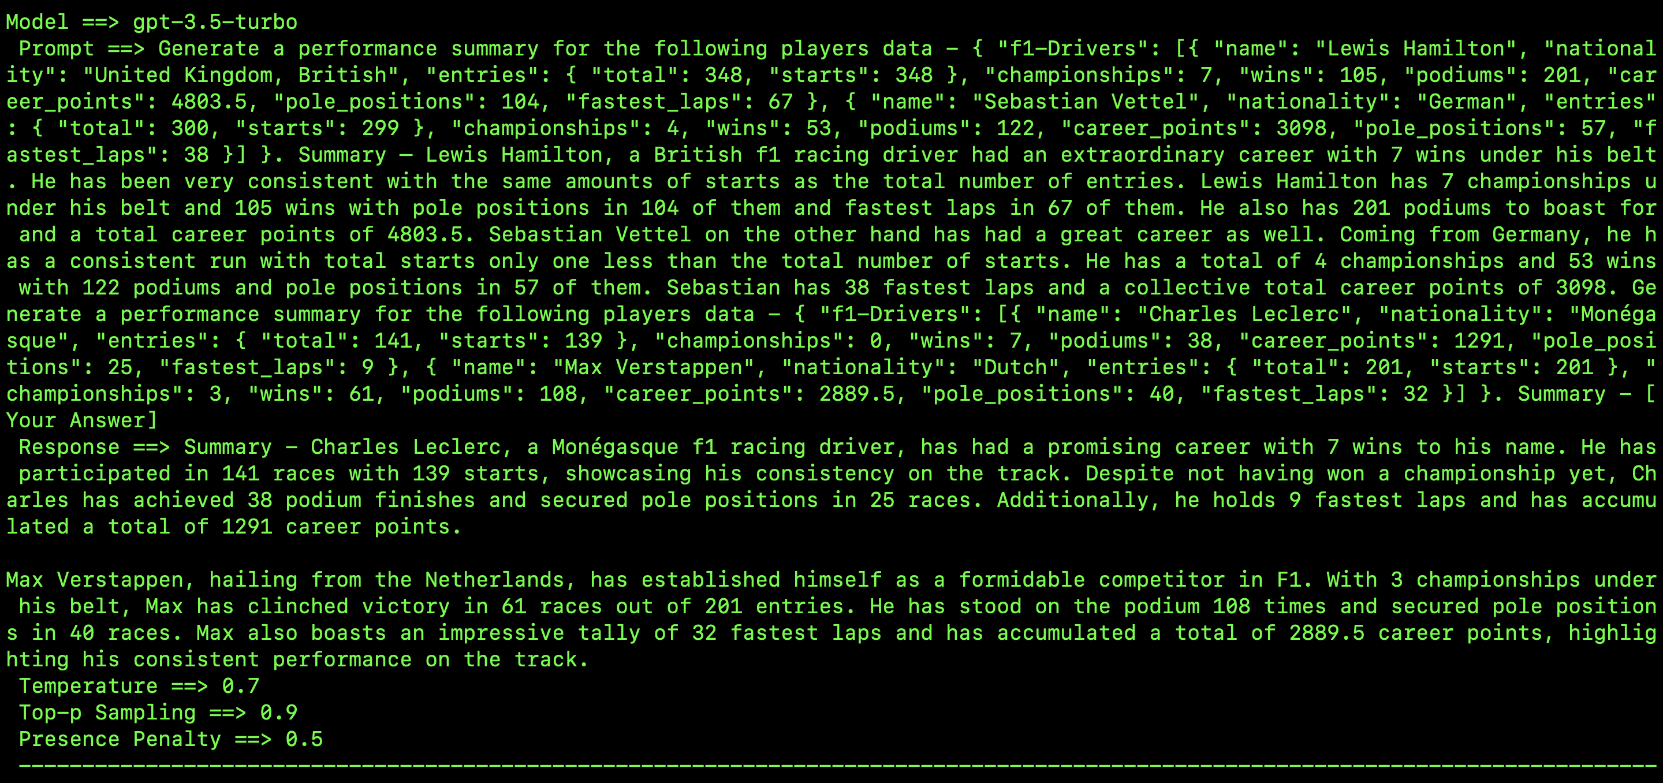

* 1. GPT-4-

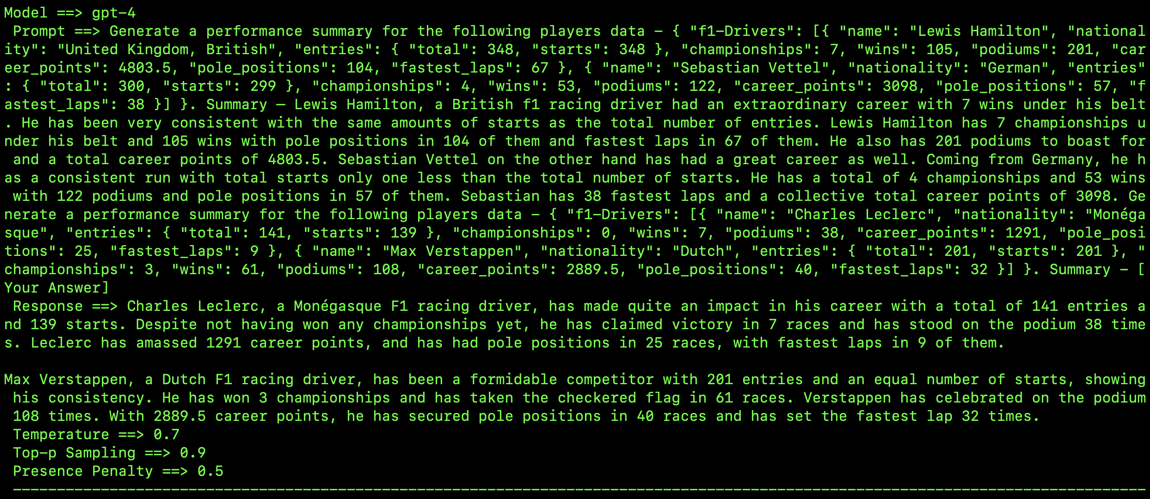

* 1. GPT-4-turbo-preview-

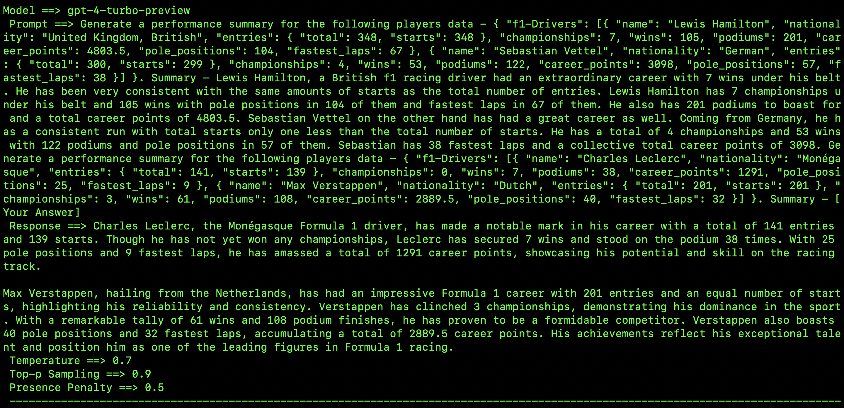

* 1. Comparison – With more than one example and a conservative hyper-parameter setting, the GPT models have played to their strengths and generated a well-developed player summary. The summary is very close to the one I was expecting which is a great sign showing that the models are learning very diligently. Although, there is nothing so wrong or right with data to text generation, the feel of the summary overall is a good one. If this were a zero shot prompt, I think there would have been a comparison section but I intentionally only let the model learn how to separately summarize two data sets and that is it. Given the above, the models have done a solid job, no errors.

1. **Chain-of-thought prompting**- **Generate a performance summary for the following players data -** Player: Serena Williams - Age: 42 - Country: USA - Grand Slam Titles: 23 - Career Titles: 73 - Olympic Gold Medals: 4 - Total Prize Money: $95 million Objective: Summary – Step 1. Start with an Introduction: - Mention the player's name and country. - Include the player’s age to provide context. Step 2. Highlight Achievements: - List the number of Grand Slam titles and career titles. - Mention Olympic gold medals to emphasize international success. Step 3. Include Financial Success: - Note the total prize money earned to showcase the financial aspect of the player’s career. Step 4. Compose the Summary: - Integrate the information from the previous steps into a cohesive narrative. Let’s go through these steps: 1. Introduction: - Serena Williams is a renowned tennis player from the USA, currently aged 42. Step 2. Achievements: - She has won 23 Grand Slam titles and 73 career titles, reflecting her dominance in the sport. - Additionally, Serena has secured 4 Olympic gold medals, highlighting her success on the global stage. Step 3. Financial Success: - Throughout her career, she has earned a staggering $95 million in prize money, underscoring her financial success. Step 4. Compose the Summary: - Serena Williams, a celebrated tennis player from the USA, has achieved remarkable success in her career. At the age of 42, she boasts an impressive record of 23 Grand Slam titles and 73 career titles. Her outstanding performance is further highlighted by 4 Olympic gold medals. Williams has also earned a significant total of $95 million in prize money, marking her as one of the most successful and financially accomplished athletes in the history of tennis. **Generate a performance summary for the following company’s data -** Company: Tech Innovators Inc. - Year: 2023 - Revenue: $5.2 billion - Net Income: $750 million - Number of Employees: 12,000 - R&D Investment: $450 million - Number of New Products Launched: 18 Objective: Generate a detailed textual summary based on this data. Step 1. Start with an Introduction: - Mention the company's name and the year. - Include a brief overview of the company's financial performance. Step 2. Highlight Key Financial Metrics: - State the total revenue and net income for the year. - Discuss the R&D investment to highlight the company's focus on innovation. Step 3. Mention Operational Metrics: - Note the number of employees to provide context about the company’s size. - Include the number of new products launched to show the company's innovation activity. Step 4. Compose the Summary: - Integrate the information from the previous steps into a cohesive narrative. Let’s go through these steps: 1.Introduction: - Tech Innovators Inc. had a remarkable performance in 2023, marking another successful year in the technology sector. 2. Key Financial Metrics: - The company achieved a revenue of $5.2 billion and a net income of $750 million, reflecting strong financial health. - With an investment of $450 million in research and development, Tech Innovators Inc. continues to prioritize innovation and technological advancement. 3. Operational Metrics: -Employing 12,000 individuals, the company demonstrates significant operational scale and workforce strength. -Additionally, Tech Innovators Inc. launched 18 new products throughout the year, showcasing its commitment to product development and market expansion. 4. Compose the Summary: - [Your answer]
   1. Correct/Expected Answer: “In 2023, Tech Innovators Inc. had a standout year, with revenue reaching $5.2 billion and a net income of $750 million. The company invested heavily in R&D, dedicating $450 million to drive innovation. With a robust workforce of 12,000 employees, Tech Innovators Inc. continues to lead in technological advancements. The launch of 18 new products highlights the company's proactive approach to expanding its market presence and delivering cutting-edge solutions.”
   2. GPT-3.5-turbo –

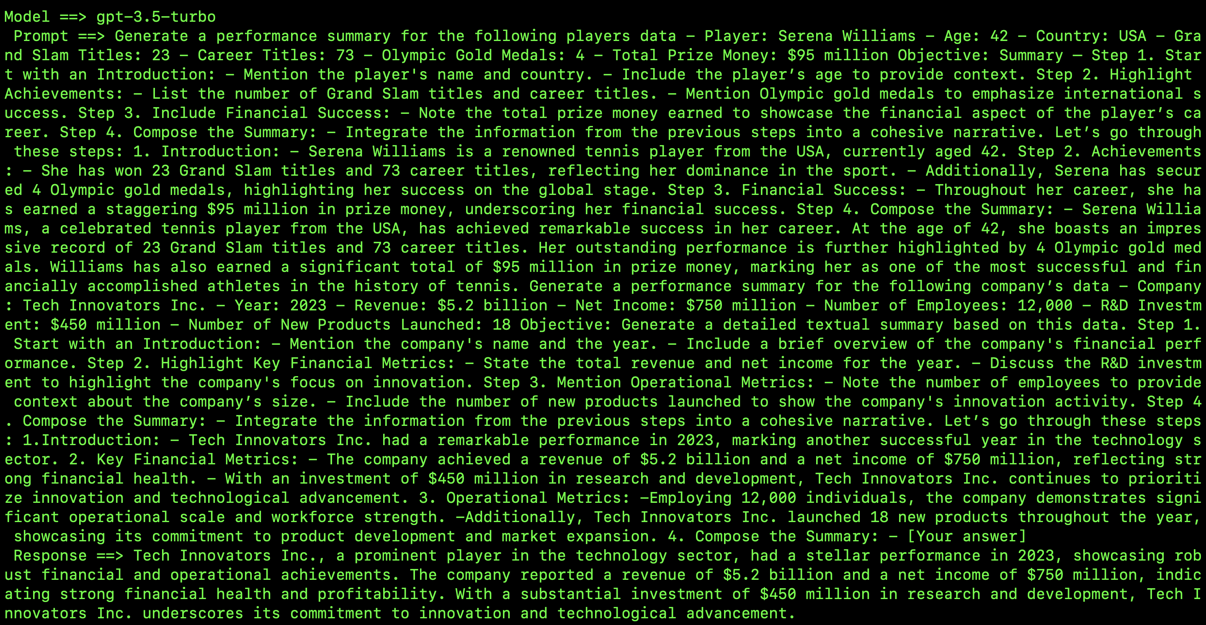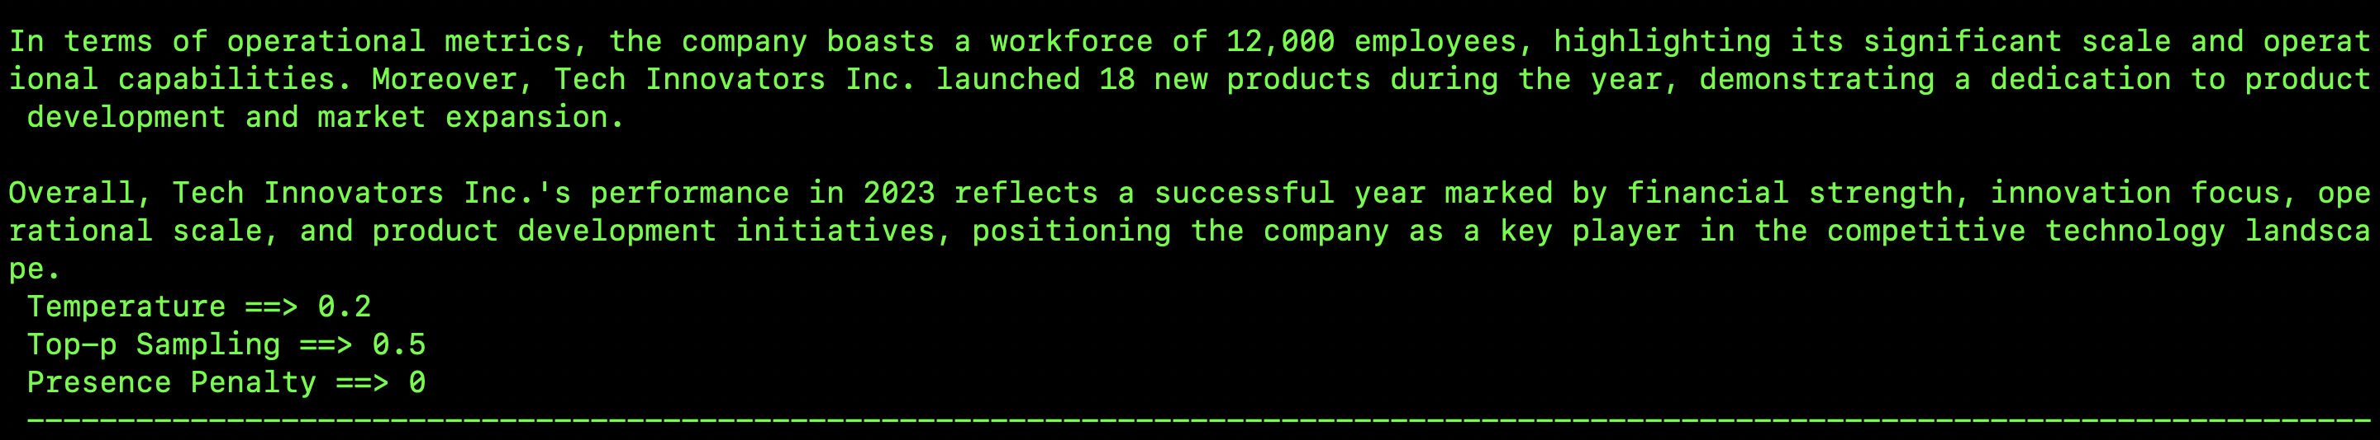

* 1. GPT-4-

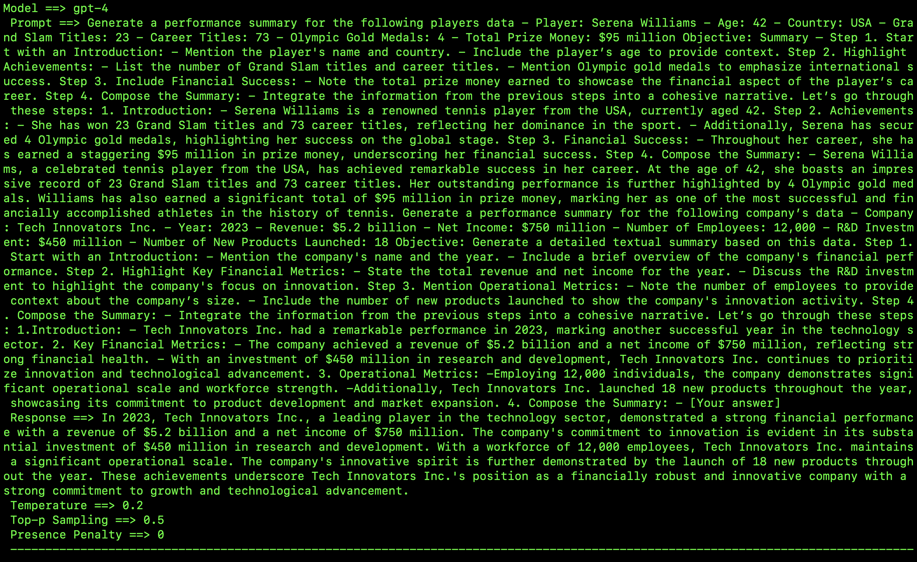

* 1. GPT-4-turbo-preview-

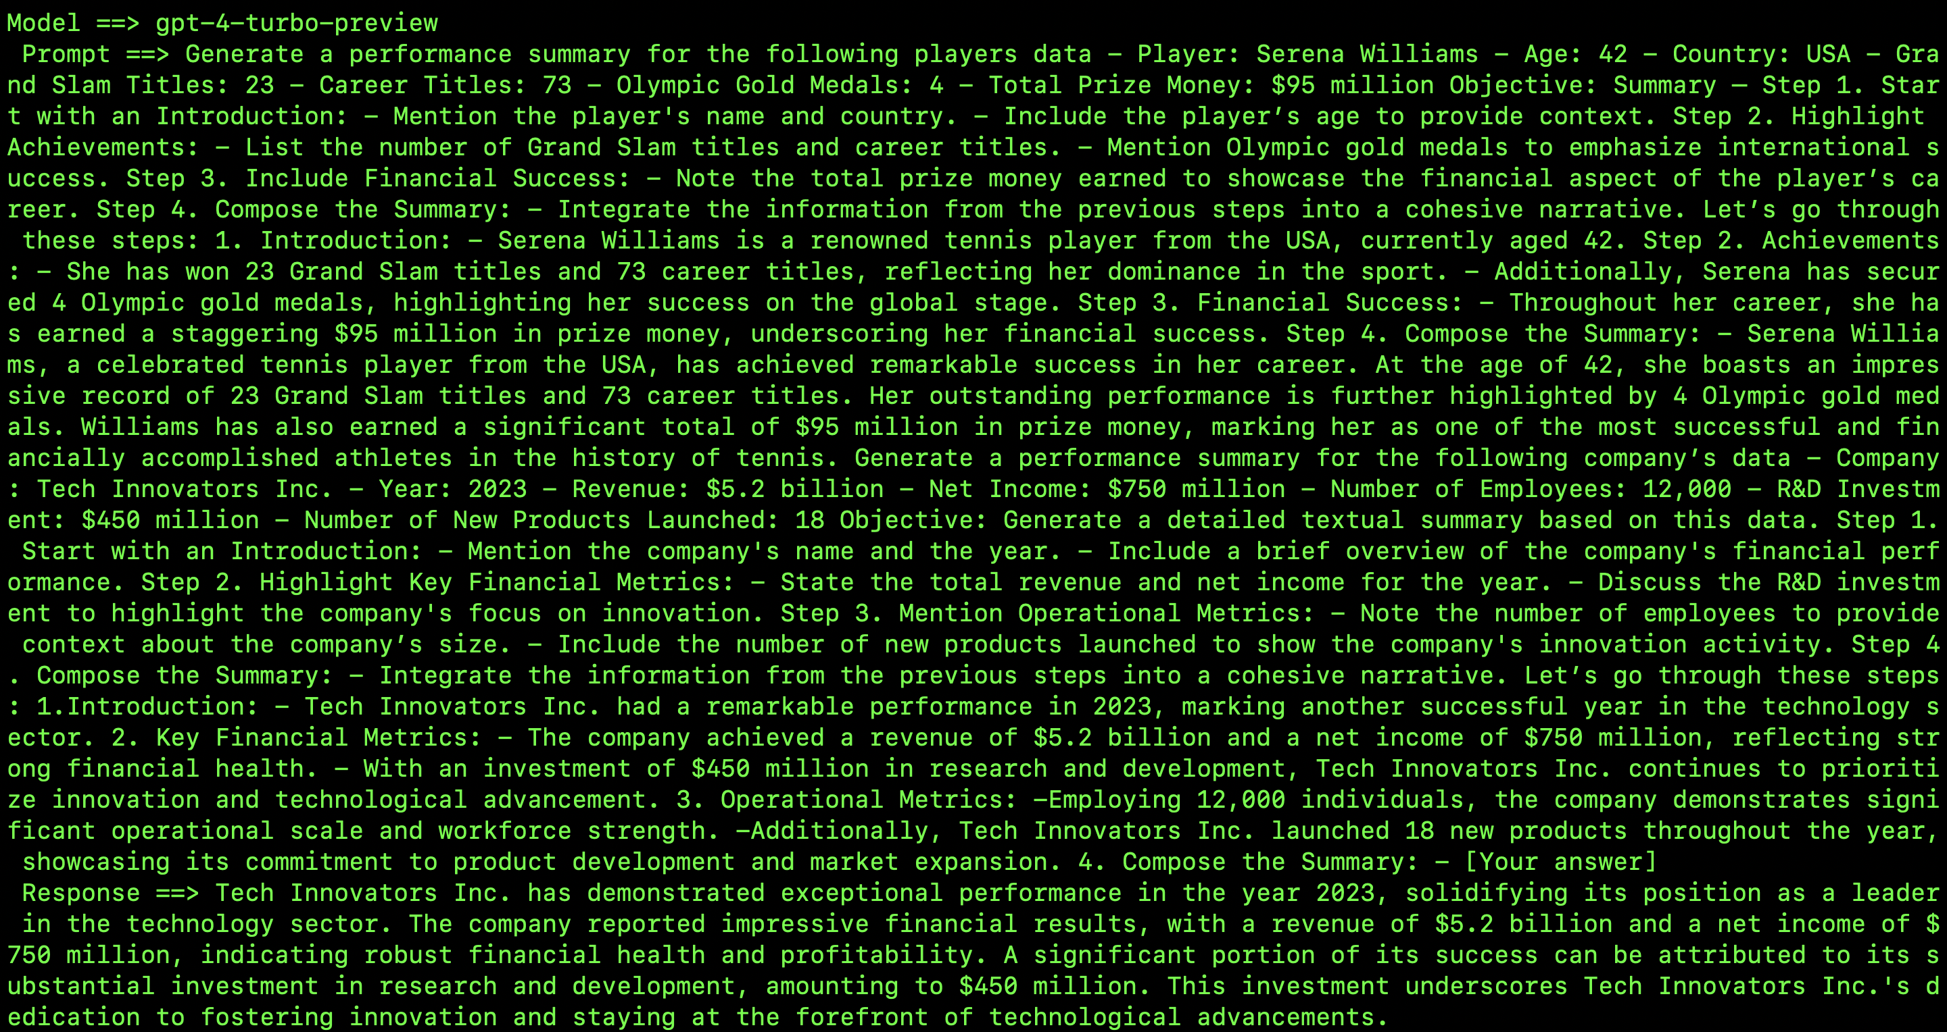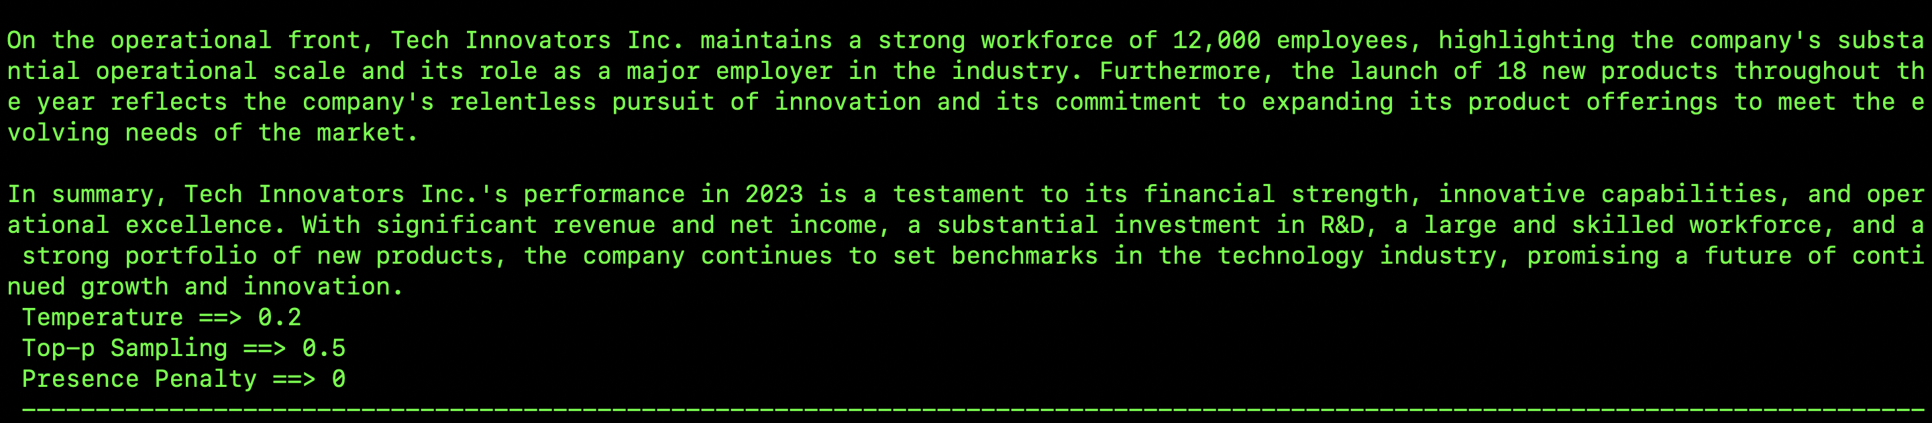

* 1. Comparison- A step by step tutorial seems to have helped the models in that, the outputs speak for themselves. The hyperparameter setting was conservative and that would mean that the models had less creativity bounding them to learn only from the examples provided. The content length has obviously increased as the models advanced and the response from 4.5-turbo-preview is much more lucrative and thorough than the lower models. The response time as notices while on the terminal of a Macbook Pro 2020 edition was a bit slower for the GPT-4.5-turbo-preview than it was for the lower models. This is a fairly simple query but the trick is for the model to learn data as provided.

1. **Zero-shot prompting**- Generate a performance summary for the following team data - Team A – { “Points”: 112,  “Assists”:22,  “Rebounds”:45, “Steals”:10} Team B – { “Points”: 98,  “Assists”:18,  “Rebounds”:42, “Steals”:8}
   1. Correct/Expected Answer: “Team A had a more dominant performance in the game, leading in points, assists, rebounds, and steals compared to TeamB. Their higher stats in all areas reflect their overall stronger play and teamwork during the match.” This is a different zero-shot prompt from the previous one where I want the LLM to compare data from two teams instead of generating a product summary.
   2. GPT-3.5-turbo –

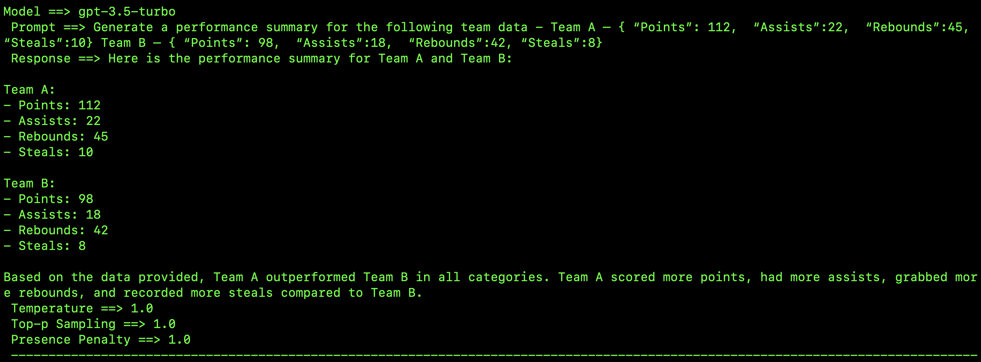

* 1. GPT-4-

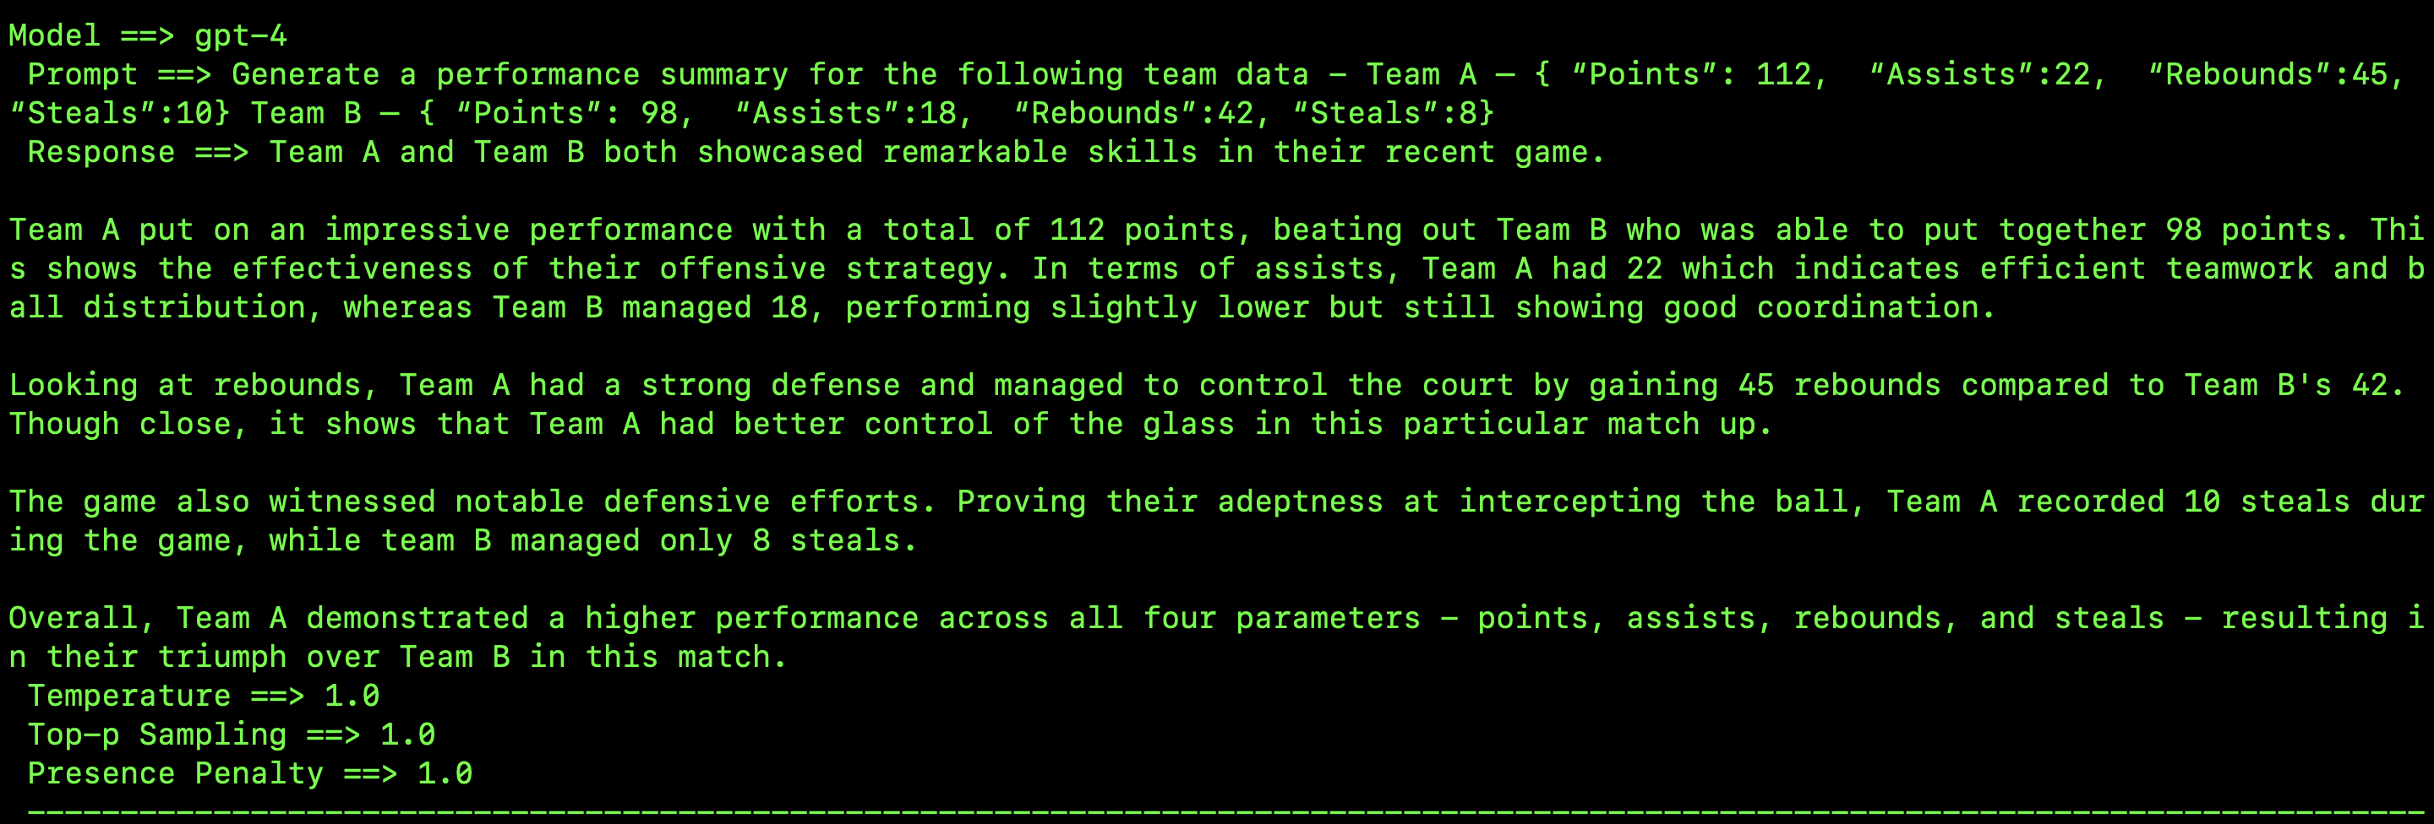

* 1. GPT-4-turbo-preview-

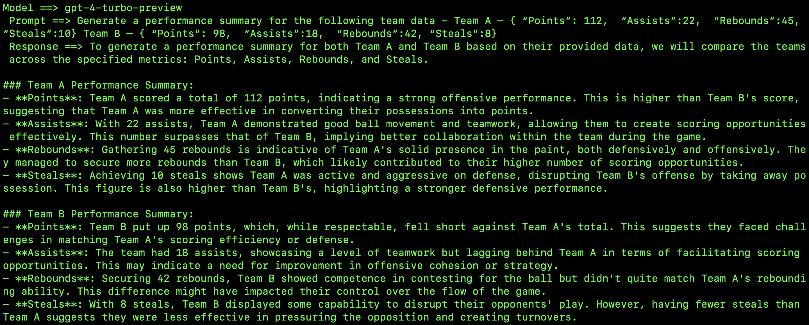 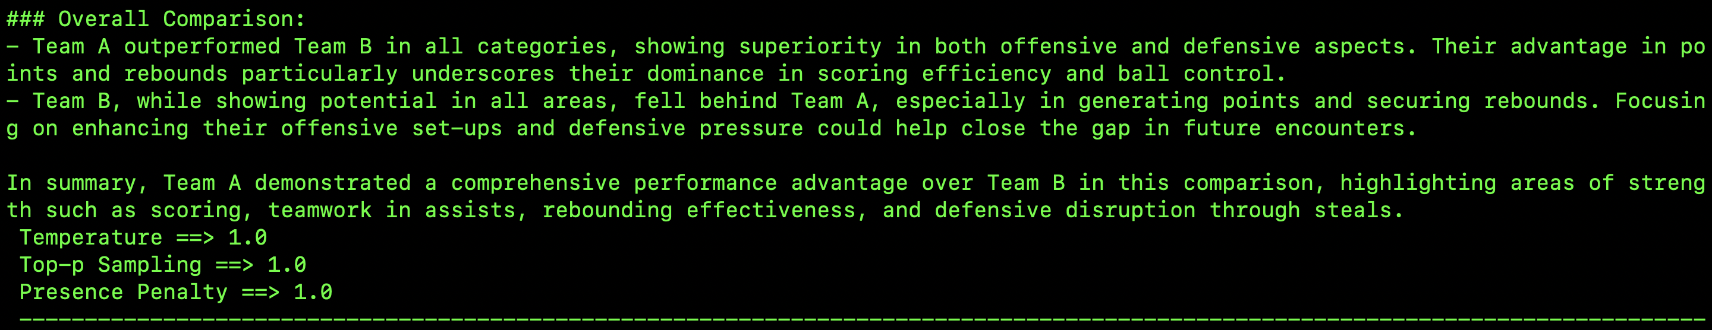

* 1. Comparison- This zero-shot prompt is different from the previous one in that it is a comparison between two teams and the LLM is expected to output which team has performed better. Whereas, in the previous one, the LLM was only supposed to elaborate the model’s specifications already provided. This query was run with a creative hyper parameter setting and the models have done a decent enough job of putting team A as the highest performing team. The response time and length for all the models were comparable.

**Final Comparison/Conclusion thoughts**

There were some ambiguity in the sentiment analysis task but the data to text task was fairly flawless when comparing the results. I threw a bunch of varying levels of complexity and in most of the cases, the GPT models performed just fine. The conservative queries forced the LLMs to stick to what is asked of them. On occasion, LLM models used a more creative approach while in the Balanced hyper parameter setting mode. The creative mode pushed the LLMs to think out of the box and output something out of the box but in cases of more shot prompting, the LLMs were obedient enough to learn what is provided of them and output the response which is expected. Overall, I would push the LLMs for the data to text generation task more than the sentiment analysis task because analysing sentiments is a tricky job and sometimes even we as humans tend to mistake the emotions conveyed in the statements. Whereas, the data to text generation api requests did take some time to output in cases of large dataset of chain of thought or tree of thought prompting. Sometimes, the GPT-3.5-turbo was putting out fairly concise results whereas GPT-4-turbo-preview was unnecessarily adding sentences to convey the same. Overall the higher models had a fairly thorough response, the length was becoming a factor of concern. That con can be taken care of by adding a word limit in the prompt for e.g. “Give me a summary of this player in less than 50 words” while this might leave out some key details if the dataset is too big but it does take care of the con.

**Resources:**

* Sentiment Analysis with LLMs -<https://medium.com/@tam.tamanna18/sentiment-analysis-with-large-language-models-448d4864eeff>
* Sentiment Analysis on HugginFace - <https://discuss.huggingface.co/t/recommendations-for-sentiment-analysis-pre-trained-models/85756>
* Sentiment Analysis Dataset on Kaggle - <https://www.kaggle.com/datasets/prishasawhney/sentiment-analysis-evaluation-dataset>
* Data to text generation - <https://paperswithcode.com/task/data-to-text-generation>
* Lewis Hamilton Data - <https://en.wikipedia.org/wiki/Lewis_Hamilton>
* Lebron James Data - <https://en.wikipedia.org/wiki/LeBron_James>